Control Card Development API Interface Manual (Java)

Revision record:
date | version | Modify content
2019-4-10 | V1.0 | The first version
2019-4-14 | V1.1.1 | Add clock, temperature and humidity, gif playitem interface
2019-4-23 | V1.1.2 | Add picture playitem interface
2019-4-28 | V1.1.3 | Send interface, add formatted text playitem interface (html)
2019-5-20 | V1.2.0 | Add multi-window protocol to send program interface
2019-5-24 | V1.2.1 | Multi-window protocol increases sending scalable pictures
2019-6-6 | V1.2.2 | Add interface for setting communication key of control card
2019-6-21 | V1.2.3 | Support communication to encryption control card (need to set key first)
2019-7-29 | V1.2.4 | Multi-window protocol: add video transmission interface (8200);
2019-8-22 | V1.2.5 | Multi-window protocol:  1, increase the timely switch screen interface;  2. Add and exit the multi-window program display interface.  Fix some known problems.
2019-12-11 | V1.2.6 | Add text alignment attribute  The program file (lpb) can be sent directly without manually generating the program list file (lpp). Automatically generated when sending. )  3. Fix some known problems
2020-3-26 | V1.3.0 | - Increase the number of the currently played program and take screenshots  - Fix some problems already
2020-4-28 | V1.3.1 | - Add a text playitem interface that supports any text size  - Add LmServerAPI interface
2020-5-27 | V1.3.2 | - Add the anycast program interface and exit the anycast interface  - Add setting variable value interface
2020-7-20 | V1.3.3 | - Add additional program file interface (FileUploadProtocol and LmServer)  - Add interfaces (ControlUtil and LmServer) for obtaining the remaining space in the program area  - Add interfaces for obtaining program file list (ControlUtil and LmServer)  - Add and delete interfaces for designated program files (ControlUtil and LmServer)  - Fix some problems already
2020-8-3 | V1.3.4 | Add serial communication interface:  Send program file interface;  Multi-window protocol  control  2. Add formatted user disk interface
2020-12-07 | V1.3.5 | 1、Add interface for sending timely information (ControlUtil)  sendInstantMsg  The LmServer adds the following interfaces  GetCardDevices: get all the devices under the login account  2、LmServer_GetScreenshot: screenshot  GetPlayingProgram: get the program information (program serial number and content) being played  GetProgramContent: get the content of the specified program  GetMultiProgramContent: get the information of all programs (program serial number and content)
2021-3-4 | V1.3.6 | 1.1.2：  AddTextItem add: sets the background color of the window, and the window is transparent  Add and send text with picture background window  4.2：  Add: the time of obtaining control card  Add: the time of setting control card  Modify: callback interface
2021-4-15 | V1.3.7 | Update catalog: 2.2  Update content: Add program template related interface:  1. Enter the program template mode  2. Send the program  3. Delete the program  4. Enter or exit the program template method
2021-5-27 | V1.3.8 | Update content:  1. Added the support for error retransmission of uploadFileRetryMode  2. Fix some problems
2022-2-16 | V1.4.0 | Update content:  1. The multi-window interface added the timeout period for receiving returned packet data  2. The multi-window interface added the timeout period for obtaining and receiving returned packet data  3.send the program new segment upload  4. multi-window increase call extended font to send text
2022-3-11 | V1.4.1 | Update content:  Increase program operation plan
2022-8-27 | V1.4.2 | Update content:  1. Multi-window protocol network initialization  2. Add the text content of window 1 to obtain the program number  3. Obtain the latest multi-window protocol sendtext content  4. Optimize timeout Settings
2022-09-19 | V1.4.3 | Update content:  1. Adjust the document to supplement the call example of the interface  2. multi-window protocol sendText method began to support the use of labels, window background color: <bkcolor=1>, text size: <size=1>, text color: <color=2>  3. Fix the file name error when creating the lpp program file  4. Add two interfaces, workload counting and timing, to the API for program generation  5. control (network) and control (serial port) increase, restart the App and restart the hardware interface  6.(2022-12-14) Control (network) Add interface: get the value of global variables;  7.LmServer added interface: sendSimpleText -- send formatted text to the specified window  8.increased control (network) : get the current screenshot interface to increase to monitor events, to be able to return the IP address of the control card, controlUtil. SetOnControlListenerNew
2023-02-06 | V1.4.4 | Update content:  1. The LmServer interface: sendSimpleText() adds the parameter compliance judgment. getCardDevices() adds one second delay when receiving the returned packet data to solve the problem of receiving incomplete data;  2.multi-window protocol (network + serial port) :  Add an interface, create a global zone window and clear all global zones;  LmServer:  The content is modified. When sending heartbeat packets, the return packets are no longer received.  3. Multi-window Protocol (Network)  Add an interface and set the high and low levels of 5 I/O ports.  4. Control (network)  Add an interface and set the high and low levels of 5 I/O ports.
2023-04-11 | V1.4.5 | Update content:  1. control, multi-window, LmSever interface added, can set the text Chinese text content as traditional Chinese, text content supports the use of color and size labels;  2. Add font labels to the content of the text program, such as <font=1>, the value is 0~7, which corresponds to the font library file in the system disk;  3. In the control interface, the time date is added to the return object of the api for obtaining program file information
2023-04-27 | V1.4.6 | Update content:  1. Add content to the interface of multi-window network and serial network: If the protocol of the card is switched to the new protocol when executing the method, the protocol of the card will be switched back to the original old protocol after execution;
2023-06-03 | V1.4.6 | Update content:  1. multi-window network interface added content: sendTextRGB() support RGB to change the text color
2023-07-24 | V1.4.6 | Update content:  1. multi-window network interface added content: sendPicture02() support call control card pre-stored gif images;
2024-01-29 | V1.4.7 | Update content:  1. In the "addTextItem" interface: all optional pixel text sizes are supported.  2.Add two parameters in the uploadFile interface, uploadFileAppend interface, uploadFileSegment Interface, and formatUserDisk interface to support WAN communication:  A. Parameter Device unique Mac address;  B.The parameter protocol type can be 0:auto, 1:old, 2:new
2024-01-30 | V1.4.7 | Update content:  1. Add the getCardMacAndPort interface to the control (network) to obtain the MAC address and port of the control card
2024-02-26 | V1.4.7 | Update content:  1. Add parameter isDeleteFileSign to the uploadFile interface and check whether the tag for deleting files is true: yes; false: no.
2024-05-09 | V1.4.7 | Update content:  1.add the getSendTextData interface in the multi-window (serial port) to get the send data (send formatted text to the specified window).

Part I: Overview

Interface classification
No | Interface | explain
1 | Generate program files and send them | Basic program delivery method, supporting various forms of program combination
2 | Run plan | Create a run plan file with the rsf extension
3 | Multi-window protocol(network) | Single program; Support multiple windows; quick
4 | Multi-window protocol(serial port) | Single program; Support multiple windows; quick
5 | control(network) | Read or set program information; Control program playing
6 | control(serial port) | Read or set program information; Control program playing
7 | LmServer | A set of remote sending interfaces, which need server support
8 | Communication key management | Set the communication key for the control card

description of parameter

1, color and gray level
name | value | A constant name (ProtocolConstant)
Single red | 0x01 | COLOR_TYPE_MONO
Dan Hong 256 gray scale | 0x71 | COLOR_TYPE_MONO_WITH_GRAY
two-tone | 0x03 | COLOR_TYPE_RG_COLOR
Two-color 256 gray scale | 0x73 | COLOR_TYPE_RG_COLOR_WITH_GRAY
various colours | 0x07 | COLOR_TYPE_RGB_COLOR
true color | 0x77 | COLOR_TYPE_FULL_COLOR

2,Coding of text and picture display effect
Example of calling: ShowEffect.Random.getEffect ();

Effect code | Effect result
Random | randomize
Instant | Show immediately
Open_left | Left open
Open_right | Open right
Open_horizontal | Hengzhongkai
Open_vertical | Open vertically
Shutter_vertical | Louver _ vertical
Shift_left | left shift
Shift_right | right shift
Shift_up | shift up
Shift_down | move down
Scroll_up | Scroll up
Scroll_left | Scroll left
Scrollleft_continuously | Scroll left continuously
Scroll_right | Scroll right
Scroll_right_continuously | Scroll right continuously
Blink | glimmer
Shutter_horizontal | Louver _ horizontal
Open_clockwise | Expand clockwise
Open_anticlockwise | Expand counterclockwise
Windmill_clockwise | windmill
Windmill_anticlockwise | Windmill _ counterclockwise
Rectangle_out | Rectangular outward
Rectangle_in | Rectangular inward
Corner_out | The four corners are outward
Corner_in | Four corners inward
Round_out | Round outward
Round_in | Circular inward
Open_top_left | Expand upper left corner
Open_top_right | Expand upper right corner
Open_bottom_left | Expand the lower left corner
Open_bottom_right | Expand lower right corner
Open_slash | Oblique expansion
Open_backslash | Anti-bevel expansion
Slide_top_left | Enter in upper left corner
Slide_top_right | Enter in upper right corner
Slide_bottom_left | Enter the lower left corner
Slide_bottom_right | Enter the lower right corner
Open_cross_in | Oblique entry
Open_cross_out | Anti-bevel entry
Zebra_cross_horizontal | Horizontal zebra crossing
Zebra_cross_vertical | Vertical zebra crossing
Mosaic_large | Mosaic _ big
Mosaic_small | Mosaic _ small
Laser_line_upward | Radioactivity _ up
Laser_line_downward | Radioactivity _ down
Scrape_up | gather
Drop_down | drop
Slide_left_right | Merge _ level
Slide_top_bottom | Merge _ vertical
Slewing_out | back-out
Slewing_in | screwing in
Chessboard_horizontal | Chessboard _ horizontal
Chessboard_vertical | Chessboard _ vertical
Scroll_up_continuously | Scroll up continuously
Scroll_down_continuously | Scroll down continuously
Expand_from_top | Gradually become larger _ up
Expand_from_bottom | Gradually get bigger _ down
Expand_vertical | Gradually getting bigger _ vertical
Blind_horizontal | Flashing _ level
Blind_vertical | Flashing _ vertical
Snow_fall | drifting snow
Scroll_down | Scroll down
Open_left_right | Expand left and right
Open_up_down | Expand up and down
Open_2_fan | Sector expansion
Slide_zebra_horizontal | Zebra bar _ level
Slide_zebra_vertical | Zebra strip _ vertical

3,Image scaling method coding
Coded value | Image processing mode | A constant value (ProtocolConstant)
0 | centre | SHOWMODE_CENTER
1 | Scale in proportion | SHOWMODE _SCALE
2 | stretching | SHOWMODE _STRETCH
3 | tile | SHOWMODE _TILED

4,Text size
Note: the dot matrix size of the extended font supported by each control card is different,If the text is not displayed under a certain size, the dot matrix size is not supported

Coded value | Text size (points) | A constant value (ProtocolConstant)
0 | 8 | FONTSIZE_8
1 | 12 | FONTSIZE_12
2 | 16 | FONTSIZE_16
3 | 24 | FONTSIZE_24
4 | 32 | FONTSIZE_32
5 | 40 | FONTSIZE_40
6 | 48 | FONTSIZE_48
7 | 56 | FONTSIZE_56

5,Clock attributes
Class: com.lumen.ledcenter3.protocol.clockattrib.

5.1,Attributes
Year: displays the year
Month: displays the month
Day: display the day
Hour: Displays the hour
Min: displays the minutes
Sec: display seconds
Week: display the week
TimeHand: display pointer
TimeDegree: displays time scales and sub-scales
Note: For the above attributes, passing 0 means not displaying, and passing 1 means displaying

TransEnable: transparent display (0: opaque; 1: transparent)
TweentyFour: time system (0: 12 hour system; 1: 24 hour system)
TwoDigitYear: year digits (0: 4 digits; 1: 2 bits)
Branch: branch (0: single line; 1: multiple lines).
TimePattern: time format and value, as follows
format | value
Friday, November 12, 2010 16:20:30 | 0
Fri，12112010 16:20:30 | 1
2010-11-12 Fri. 16:20:30 | 2
Friday，12 November 2010 16:20:30 | 3
Fri，Nov 12,2010 16:20:30 | 4
Friday，November 12 2010 16:20:30 | 5
Fri，11122010 16:20:30 | 6
20101112，Fri.16:20:30 | 7

5.2,Default options
Check to display as shown in the following figure
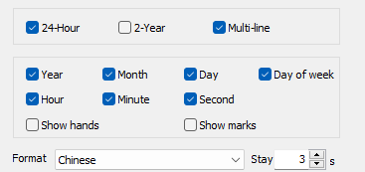

5.3,Instructions for use
1,using an empty constructor is the default option

6,Time zone adjustment value
Target time zone minus local time zone.
For example, if the local time zone is +08:00 and the target time zone is +03:00, the adjusted value is -05:00 .

Part II: Interface Details

1,generate and send program files

1.1,API interface for generating programs
The following interfaces are all in the com.lumen.ledcenter3.protocol.programcreator class.

1.1.1 overview of API interface for program generation
No | API interface function name | Interface description | completeness
1 | ProgramCreator constructor | Create a program object | Achieved
2 | addWindow | Add a play window to the program | Achieved
3 | addTextItem | Add protocol text playitems to the specified window | Achieved
4 | addPicture | Add picture playitems to the specified window | Achieved
5 | addAnimator | Adds animation (gif) playitems to the specified window | Achieved
6 | addClock | Add a clock playitem to the specified window | Achieved
7 | addTemperature | Adds a temperature playitem to the specified window | Achieved
8 | addHumidity | Add humidity playitems to the specified window | Achieved
9 | createLpbFile | Create a program file and save the program to the file | Achieved
10 | addExtraTextItem | Adds a text playitem to the specified window (supports fonts of any size) | Achieved
11 | addFormTextItem | Add a text playitem (HTML text) to the specified window | Achieved
12 | addTextItemWithPictureBackground | Adds a background image text player to the specified window | Achieved
13 | addWorkCounter | Work count | Achieved
14 | addTimeCounter | timekeeping | Achieved
15 | setTextComplex | Set the text in the text program to traditional Chinese | Achieved
16 | getTextComplex | Gets whether the text in the text program is in traditional Chinese | Achieved

The use steps of this kind of function are as follows:
Step 1: Create program objects
Step 2: Increase the playback window
Step 3: Add play items to the designated play window
Step 4: Create an Lpb file and save the program to the file

1.1.2,Detailed description of API interface for program generation

ProgramCreator
ProgramCreator (int screenWidth, int screenHeight, int colorType)
function | Create a program object
parameter | ScreenWidth: the width of the display screen in points
 | ScreenHeight: the height of the display screen in points
 | ColorType: color and gray level. color and gray level
Return value | without
Other instructions | Unique constructor

addWindow
int addWindow (int startX, int startY, int windowWidth, int windowHeight)
function | Add a play window to the program
parameter | StartX: the starting X coordinate of the playback window
 | StartY: the starting Y coordinate of the playback window
 | WindowWidth: width of playing window
 | WindowHeight: height of playing window
Return value | Playback window serial number
Other instructions | When adding a playitem, specify the playwindow serial number

Add text item (modified in v1.3.6)
ProgramCreator addTextItem (int winNo, String textContent, int textColor, int textSize, int speed, int stayTime, int showEffect, int hAlign, int vAlign, int lineTween,
boolean windowTransparent, int winColor)
function | Add text items to the specified playback window
parameter | WinNo: play window number
 | TextContent: Text string, supporting the use of text labels, fonts, colors, sizes
TextSize: text size , text size
Use constant values:
24 pixels:ProtocolConstant.FONTSIZE_24
16 pixels:ProtocolConstant.FONTSIZE_16
 | TextColor: text color,Such as 0x00ffffff
 | ShowEffect: text display effect , Coding of text and picture display effect
 | Speed: the speed of text display
 | StayTime: stay time
 | (the following are optional parameters)
 | HAlign: horizontal alignment: 0- left; 1- medium; 2- right
 | VAlign: vertical alignment: 0- up; 1- medium; 2- down
 | LineTween: line spacing (0-15)
 | WindowTransparent：Whether the background is transparent (default is opaque)
 | WinColor: background color value (default is black)
Return value | Current program object
Other instructions | Plain text program

addTextItem (Expanded font library, new V1.4.0)
ProgramCreator addTextItem (int winNo, String textContent, int textColor, int textSize, int speed, int stayTime, int showEffect, int hAlign, int vAlign, int lineTween,
Int winColor, int isExt)
function | Add text items to the specified playback window
parameter | WinNo: play window number
 | TextContent: a text string
 | TextColor: text color
TextSize: text size ， text size
Use constant values:
24 pixels:ProtocolConstant.FONTSIZE_24
16 pixels:ProtocolConstant.FONTSIZE_16
 | Speed: the speed of text display
 | StayTime: stay time
 | ShowEffect: text display effect， Coding of text and picture display effect
 | (the following are optional parameters)
 | HAlign: horizontal alignment: 0- left; 1- medium; 2- right
 | VAlign: vertical alignment: 0- up; 1- medium; 2- down
 | LineTween: line spacing (0-15)
 | BackPicturePath: background picture path (absolute path)
Return value | Current program object
Other instructions | Plain text program

addPicture
ProgramCreator addPicture(int winNo, String picFile, int showMode, int showEffect, int speed, int stayTime)
function | Add picture items to the specified playback window
parameter | WinNo: play window number
 | PicFile: path and name of picture file
 | ShowMode: Processing mode when displaying ,Image scaling method coding
 | ShowEffect: picture display effect ,Coding of text and picture display effect
 | Speed: the display speed of the effect. 0 is the fastest
 | StayTime: stay time, in seconds
Return value | Current program object
Other instructions

addAnimator
ProgramCreator addAnimator(int winNo, String aniFile, int showMode, int repeat)
function | Add animation items to the specified playback window
parameter | WinNo: play window number
 | AniFile: path and name of animation file (.gif)
 | ShowMode: Processing mode when displaying , image scaling encoding
 | Repeat: the number of times the animation plays in a loop
Return value | Current program object
Other instructions

addClock
ProgramCreator addClock(int winNo, String extraText, int textSize, int textColor, int stayTime, ClockAttrib clockAttrib, String timeZoneAjustValue)
function | Add clock items to the specified playback window
parameter | WinNo: play window number
 | ExtraText: a text string
 | TextColor: text color
 | TextSize: text size ， text size
 | StayTime: stay time
 | ClockAttrib: clock attribute , clock attribute
 | TimeZoneAjustValue: time zone adjustment value , time zone adjustment value
Return value | Current program object
Other instructions

addTemperature
ProgramCreator addTemperature(int winNo, String extraText, int textSize, int textColor, int stayTime, int tempAttrib)
function | Add a temperature item to the specified playback window
parameter | WinNo: play window number
 | ExtraText: a text string
 | TextSize: text size , text size
 | TextColor: text color
 | StayTime: stay time
TempAttrib: temperature attribute
0: Celsius temperature
1: Fahrenheit temperature
Return value | Current program object
Other instructions

addHumidity
ProgramCreator addHumidity(int winNo, String extraText, int textSize, int textColor, int stayTime)
function | Add humidity items to the designated playback window
parameter | WinNo: play window number
 | ExtraText: a text string
 | TextSize: text size , text size
 | TextColor: text color
 | StayTime: stay time
Return value | Current program object
Other instructions

createLpbFile
void createLpbFile (String path, String fileName)
function | Create a program file and save the program to the file
parameter | Path: Lpb file storage directory
 | FileName: file name. The file name cannot exceed 8 bytes (2 Chinese characters or 8 numbers and letters)
Return value | without
Other instructions

addExtraTextItem
ProgramCreator addExtraTextItem (int winNo, String textContent, int textColor,
int textSize, String fontFamily, int speed, int stayTime, int showEffect, int hAlign, int vAlign, int lineSpace)
function | Adds a text playitem to the specified window (supports fonts of any size)
parameter | WinNo: play window number  TextContent: text content  TextColor: text color value, such as 0xff0000  TextSize: text size (in pixels)  FontFamily: fonts, such as' Tahoma', must be existing fonts on the computer  Speed: the text display speed is 0-100, and the larger it is, the faster it is (related to the display effect showEffect)  StayTime: the text stay time  ShowEffect: text display effect, Coding of text and picture display effect  HAlign: horizontally aligned, 0 left 1 middle 2 right  VAlign: vertically aligned, 0 up 1 middle 2 down  LineSpace: Line spacing (in pixels)
Return value | Current program object
Other instructions

addFormatTextItem
ProgramCreator addTextItem (int winNo, String htmlContent, int speed, int stayTime, int showEffect)
function | Add text items to the specified playback window
parameter | WinNo: play window number
Htmlcontent: strings in html format, such as:
"<p><span style=\"color:#FF0000; font-size:18px; Font-family: Chinese script; \">Welcome<span><p>"
ShowEffect: text display effect , text and picture display effect coding
Common effect: Scrollleft_continuously scroll left continuously
 | Speed: the speed of text display
 | StayTime: stay time
Return value | Current program object
Other instructions | 1、Html does not support js and < img >  2、< META > or < meta > tags are not supported in Html

addTextItemWithPictureBackground（Added in V1.3.6）
ProgramCreator addTextItemWithPictureBackground(int winNo, String textContent, int textColor, int textSize, int speed, int stayTime, int showEffect, int hAlign, int vAlign, int lineTween, String backPicturePath)
function | Adds a text item to the specified playwindow
parameter | winNo: indicates the player window number
 | textContent: text string
textSize: Text size
Use constant values:
24 pixels：ProtocolConstant.FONTSIZE_24
16 pixels：ProtocolConstant.FONTSIZE_16
 | textColor: text color
 | showEffect: text display effect
 | speed: text display speed
 | stayTime: residence time
 | (The following parameters are optional)
 | hAlign: Horizontal alignment: 0-left; 1- medium; 2- Right
 | vAlign: Vertical alignment: 0- up; 1- medium; 2- Down
 | lineTween: Line spacing (0-15)
 | backPicturePath: Background image path (absolute path)
Return value | Current program object
Other instructions | Text-only program

addWorkCounter （Added in V1.4.3）
Example of the method:

ProgramCreator addWorkCounter (int winNo, int textColor, int textSize, int stayTime, int countType, int hoursOfDay,int selectedWeek, int valueAdjust, int startFrom, int baseDateYear,int baseDateMonth,int baseDateDay)
function | Adds a work count to the specified playback window
parameter | winNo: indicates the player window number
 | textColor: text color
 | textSize: indicates the text size
 | stayTime: residence time
 | countType: indicates the count type. 0: number of days, 1: number of hours
 | hoursOfDay: How many hours are worked in a day
selectedWeek: The day of the week is selected;
For example, 0011 1110 indicates that Sunday and Saturday are not selected, and all other bits are selected. Sunday is the first bit, Monday is the second bit, 0 is not selected, and 1 is selected
 | valueAdjust: Adjusts the value
 | startFrom: What time do you start
 | baseDateYear: indicates the year of the base date
 | baseDatelonth: The month of the base date
 | baseDateDay: indicates the day of the base date
Return value | Current program object
Other instructions

addTimeCounter （Added in V1.4.3）
Example of the method:

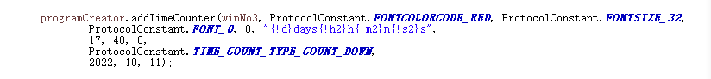

ProgramCreator addTimeCounter (int winNo, int textColor, int textSize,int fontIndex, int stayTime,String timeCountContent, int baseTimeHour,int baseTimeMinute,int baseTimeSecond,int timeCountType,int baseDateYear,int baseDateMonth,int baseDateDay)
function | Adds a timer to the specified playback window
parameter | winNo: indicates the player window number
 | textColor: text color
 | textSize: Text size
 | fontIndex: indicates the font index. The value ranges from 0 to 7
 | stayTime: residence time
 | timeCountContent：Timing content; For example: "{! d}days”
 | baseTimeHour:The base time
 | baseTimeMinute：The minutes of the base time
 | baseTimeSecond：Second of the base time
 | timeCountType：Timing type; 0: active timer, 1: countdown timer
 | baseDateYear：The year of the base date
 | baseDateMonth：Month of the base date
 | baseDateDay：The day of the base date
Return value | Current program object
Other instructions

setTextComplex（Added in V1.4.5）
void setTextComplex (int textComplex)
function | Sets whether the text in the program is in traditional Chinese
parameter | textComplex: indicates whether the text is traditional, 0: no, 1: traditional
Return value
Other instructions

getTextComplex（Added in V1.4.5）
int getTextComplex ()
function | Check whether the text in the text program is in traditional Chinese
parameter
Return value | textComplex: indicates whether the text is traditional, 0: no, 1: traditional
Other instructions

1.1.3,Demo calling example
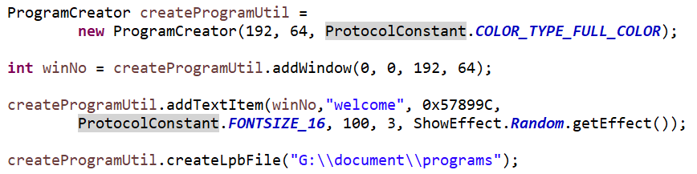

1.2,API interface for generating program list
Note: After the program file is generated, it can be sent directly by using the interface of "Send Program File", without having to create a program list.
The following interfaces are all in the com.lumen.ledcenter3.protocol.playbillcreator class

1.2.1 overview of API interface for program list generation
serial number | API interface function name | Interface description | completeness
one | PlaybillCreator constructor | Create program guide object | Achieved
2 | addLpbFile | Add program files to the program list | Achieved
three | createLppFile | Create a program guide file and save the program guide to the file | Achieved

The use steps of this kind of function are as follows:
Step 1: Create a program guide object
Step 2: Add program files to the program list
Step 3: Save the program to a file

1.2.2,detailed description of API interface for program list generation

PlaybillCreator constructor
PlaybillCreator (int screenWidth, int screenHeight, int colorType)
function | Create program guide object
parameter | ScreenWidth: the width of the display screen in points
 | ScreenHeight: the height of the display screen in points
 | Color: color and gray level. 1.4, color and gray level
Return value | without
Other instructions

addLpbFile
PlaybillCreator addLpbFile (String filepath)
function | Add program files to the program list
parameter | Filepath: the program file path
Return value | Program object
Other instructions
Other instructions

createLppFile
void createLppFile (String path)
function | Save the program to a file
parameter | Path: save the directory of the program
Return value | without
Other instructions

1.2.3,Demo calling example
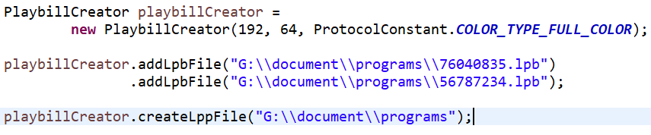

1.3,interface for sending program files
Network:
com.lumen.ledcenter3.protocol.FileUploadProtocol
com.lumen.ledcenter3.protocol.FileUploadProtocol.OnUploadListener
Serial port: (added in V1.3.4)
com.lumen.ledcenter3.protocol.FileUpload_COM
com.lumen.ledcenter3.protocol.FileUpload_COM.OnUploadListener

1.3.1,Overview of interface for sending program files
FileUploadProtocol
serial number | API interface function name | Interface description
1 | setListener | Set send listener
2 | uploadFile | Send program file
3 | uploadFileAppend | Additional transmission program file
4 | uploadFileSegment | upload files

FileUploadProtocol.OnUploadListener
serial number | API interface function name | Interface description
1 | onStatus | Listen for connection status
2 | onProcess | Monitor the sending progress
FileUpload_COM
serial number | API interface function name | Interface description
1 | setUploadListener | Set send listener
2 | uploadFile | Send program file

FileUpload_COM.OnUploadListener
serial number | API interface function name | Interface description
1 | onStatus | Listen for connection status
2 | onProcess | Monitor the sending progress

1.3.2,Detailed description of program transmission interface

Network:

setListener
void setListener (OnUploadListener listener)
function | Set up a sending monitor to monitor the sending progress and connection status of programs
parameter | Listener: Listener object
Return value | without
Other instructions

uploadFile
void uploadFile(String tempDir, List<String> lpdFilePaths, int screenWidth, int screenHeight, int colorType, String ip, int port, int socketindex)
function | Send program file
parameter | TempDir: directory where temporary files are stored
 | LpdFilePaths: list of lpd file paths to send
 | ScreenWidth: screen width. It needs to be consistent with the program file
 | ScreenHeight: screen height. It needs to be consistent with the program file
 | ColorType: screen color and gray level. It needs to be consistent with the program file
 | Ip: control card communication IP
 | Port: control card communication port
 | Socketindex: network communication number
 | deviceMac: unique Mac address of a device
 | protocolModel: indicates that the protocol type is 0:auto, 1:old, and 2:new
 | isDeleteFileSign: Indicates whether to delete files. = true: yes, false: no
Return value | without
Other instructions | 1、Temporary folders and files will be generated during sending, and will be cleared next time (same sending number);  2、This interface is network communication, which takes a long time. Please call it in the child thread

Upload file append (added in v1.3.3)
void uploadFileAppend(String tempDir, List<String> lpdFilePaths, int screenWidth, int screenHeight, int colorType, String ip, int port, int socketindex)
function | Additional transmission program file
parameter | TempDir: directory where temporary files are stored
 | LpdFilePaths: list of lpd file paths to send
 | ScreenWidth: screen width. It needs to be consistent with the program file
 | ScreenHeight: screen height. It needs to be consistent with the program file
 | ColorType: screen color and gray level. It needs to be consistent with the program file
 | Ip: control card communication IP
 | Port: control card communication port
 | Socketindex: network communication number
 | deviceMac (Optional) : unique Mac address of a device
 | protocolModel (Optional) : indicates a protocol type of 0:auto, 1:old, and 2:new
Return value | without
Other instructions | 3、Temporary folders and files will be generated during sending, and will be cleared next time (same sending number);  4、This interface is network communication, which takes a long time. Please call it in the child thread

uploadFileSegment（Segmented upload - New in V1.4.0）
void uploadFileSegment(int fileType, boolean isSystemFile, String filePath, int sendIndex)
function | upload files
parameter | fileTypeParam: indicates the file type. 1: indicates a common file
 | isSystemFile: indicates whether it is a system disk file. true: indicates a system disk file; false: indicates a user disk file
 | filePath : indicates the file path
 | sendIndex: indicates the index of the current file
 | deviceMac (Optional) : unique Mac address of a device
 | protocolModel (Optional) : indicates a protocol type of 0:auto, 1:old, and 2:new
Return value | Without
Other instructions | 5. This interface is used for network communication, which takes a long time. Please call it in the subthread  Note: methods in com) lumen. Ledcenter3. Protocol. The FileUpload_Net call in the class.  Example of parameters Protocol Type and Mac Address: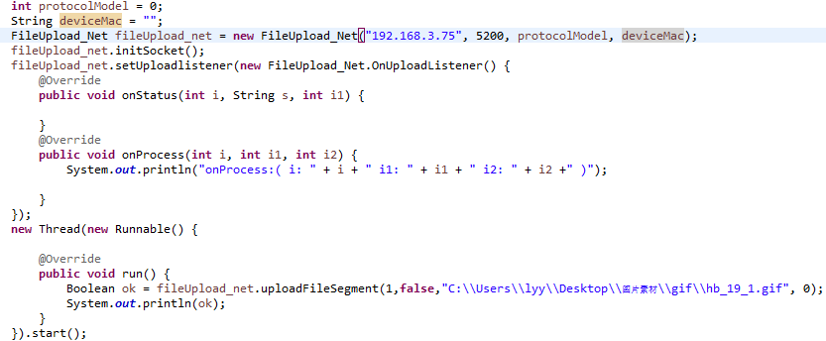

onStatus
void onStatus (int status, int socketindex)
function | Receive the network connection status
parameter | Status: connection status, 0 is connection failure, 1 is success, and -1 is exception
 | Socketindex; Network communication number
Return value | without
Other instructions

onProcess
void onProcess (int process, int totalprocess, int socketindex)
function | File upload progress
parameter | Process: current progress (uploaded data size)
 | Totalprocess: total progress (total data size)
 | Socketindex; Network communication number
Return value | without
Other instructions

Serial port: (added in V1.3.4)

setUploadListener
void setUploadListener (OnUploadListener listener)
function | Set up a sending monitor to monitor the sending progress and connection status of programs
parameter | Listener: Listener object
Return value | without
Other instructions

uploadFile
void uploadFile(String tempDir, List<String> lpdFilePaths, int screenWidth, int screenHeight, int colorType, String portName, int baudrate, int sendIndex)
function | Send program file
parameter | TempDir: directory where temporary files are stored
 | LpdFilePaths: list of lpd file paths to send
 | ScreenWidth: screen width. It needs to be consistent with the program file
 | ScreenHeight: screen height. It needs to be consistent with the program file
 | ColorType: screen color and gray level. It needs to be consistent with the program file
 | PortName: serial port number of control card
 | Baudrate: control the baud rate of serial port
 | SendIndex: communication number
Return value | without
Other instructions | 6、Temporary folders and files will be generated during sending, and will be cleared next time (same sending number);  7、This interface is network communication, which takes a long time. Please call it in the child thread

onStatus
void onStatus (int status, int sendIndex)
function | Receive serial port connection status
parameter | Status: connection status, 0 is connection failure, 1 is success, and -1 is exception
 | sendIndex; Communication number
Return value | without
Other instructions

onProcess
void onProcess (int process, int totalprocess, int sendIndex)
function | File upload progress
parameter | Process: current progress (uploaded data size)
 | Totalprocess: total progress (total data size)
 | sendIndex; Communication number
Return value | without
Other instructions

1.3.3,Demo calling example
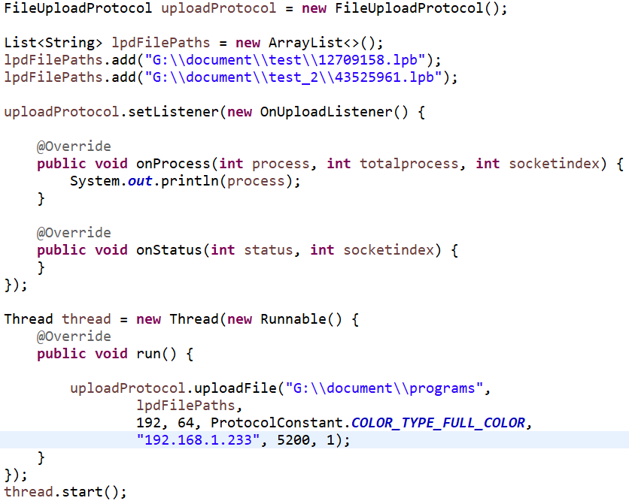

2.Operation Plan (added in V1.4.1)

2.1 Overview of the Run Plan Interface
1 | new CreateFile | Create a run plan object
2 | void addItem | Add a run plan item
3 | int saveToFile | Save the run plan to a file

Call example
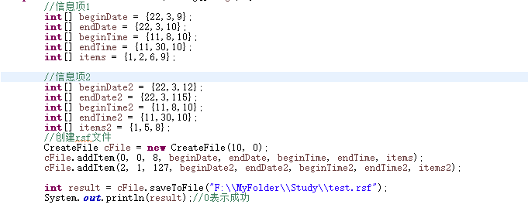

Operational plan details

new CreateFile(int proSum, int attrib);
CreateFile cFile = new CreateFile(int proSum, int attrib);
function | Create a run plan object
parameter | proSum: Total number of programs
attrib: attributes
0: No program is played in the default time range
1: All programs are played within the default time range
returned value | Without
Other instructions

void addItem(…params)
void addItem(int nGrade, int nWeekDateRelative, int nWeeks,
int[] pBeginDate, int[] pEndDate, int[] pBeginTime,
int[] pEndTime, int[] pItems)
function | Add a run plan item
parameter | nGrade: Project level. The higher the level from 0 to 9, the higher the priority.
nWeekDateRelative: Relation of week to date
0: The plan shall be executed only when both the week and the date are met
1: Execute this plan when one of the weeks or dates is met
nWeeks: Indicates the mark of the week, which can be one or a combination of the following values
1: Sunday
2: Monday
4: Tuesday
8: Wednesday
16: Thursday
32: Friday
64: Saturday
 | pBeginDate: indicates the start date. Three integer values represent "year", "month" and "day" respectively.
 | pEndDate: indicates the end date. Three integer values represent "year", "month" and "day" respectively.
 | pBeginTime: indicates the start time. The three integer values represent "hours", "minutes" and "seconds" respectively.
 | pEndTime: indicates the end time. The three integer values represent "hours", "minutes" and "seconds" respectively.
 | pItems: The number of the program to be played. Each integer is the number of the program to be played, numbered from 1 and less than the number specified by "proSum" in the first parameter of new CreateFile(int proSum,int attrib)
returned value

Other instructions

int saveToFile(String fileName)；
int saveToFile(String fileName)
function | Save the run plan to a file
parameter | fileName: indicates the file path and name
returned value | >=0: Success  <0: failed
Other instructions

3,Multi-window protocol（Network）

com.lumen.ledcenter3.protocol.ExtSendUtil
Program sending process:
- Invoke initNetwork to initialize network communication parameters
- Call setListener to set listener and listen to communication status
(Please call the following interface in the worker thread)
- Call splitScreen to split windows
- Call sendXXX to send programs

com.lumen.ledcenter3.protocol.ExternalNetworkSendProtocol.OnTcpNetWorkListener
Call example
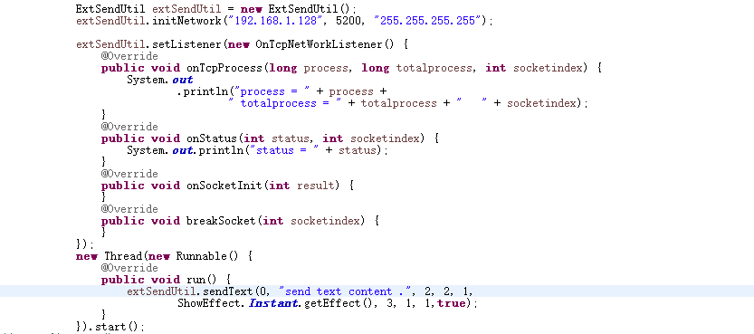

3.1,overview
ExtSendUtil.
 | Name | Description
1 | initNetwork | Initialize network parameters
2 | setListener | Set up network communication listener
3 | splitScreen | Split window
4 | sendText | Send text
5 | sendPicture | Send pictures (including jpg.png.gif)
6 | sendPictureWithScale | Send pictures, you can set zoom (gif is not supported)
 | sendVideo | Send video
7 | saveSentDataToFlash | Save the transmitted program
8 | clearSavedDataFromFlash | Don't save the transmitted program (it will be cleared after restarting)
9 | getBrightness | Get brightness
10 | setBrightness | Set brightness
11 | setScreenOnAndOffTime | Set the switch screen time
12 | getScreenOnAndOffTime | Get the switch screen time
13 | exitSetScreenOnAndOffTime | There is no automatic switch screen
14 | setScreenSwitch | Open and close the screen immediately
15 | quitExternalScreen | Exit the multi-window program
16 | selectPlayProgram | Selective broadcasting program
17 | exitSelectPlay | Quit the selective broadcast program
18 | setVariableValue | Set variable value
19 | ReadyToUseProgramTemplate | Ready to enter the template mode to display the program
20 | SendTemplateProgram | Send template program
21 | deleteTemplateProgram | Deletes a program with a specified serial number
22 | enterOrExitTemplateProgramMode | Enter or exit a program template
23 | setReceiveTimeout | Set the timeout period for receiving returned packet data
24 | getReceiveTimeout | Gets the timeout period for receiving returned packet data
27 | createGlobalAreaWindow | Create a global area window
28 | clearAllGlobalArea | Clear all global zones
29 | setIO | Set the high and low levels of the five I/O ports
30 | setTextComplex | Set the text in the text program to traditional Chinese
31 | getTextComplex | Gets whether the text in the text program is in traditional Chinese

OnTcpNetWorkListener
No | Name | Description
1 | onSocketInit | Network initialization
2 | onStatus | Communication status
3 | onBackBytes | Data returned
4 | onTcpProcess | Upload progress (when sending pictures or files)
5 | breakSocket | Network disconnection

3.2、Detail description

initNetwork (Updated 1.4.2)
initNetwork (String ip, int port, String idcode)
Use | Initialize network parameters
Params | Ip : control card’s network ip address  Port: net port , default 5200  Idcode: default 255.255.255.255
initNetwork (String ip, int port, String mac, int protocolMode)
Use | Initializing network parameters (WAN/cross-route calls)
Params | Ip : control card’s network ip address  Port: net port , default 5200  mac: device mac address  protocolMode:0:auto, 1:old, 2:new

setListener
setListener (OnTcpNetWorkListener listener)
Use | Set up network communication listener
Params | Listener: Monitor the network communicate status and progress

splitScreen
boolean splitScreen(int windowCount, int[]... winRects)
Use | Divided into windows, with a maximum of 8. To save the program to flash memory, you must call.
Params | windowCount: The number of windows to be split, and within the limits of 1 to 8.  winRects：array of windows’s rects.  winRect is The coordinates of a window. Each window uses four integers to represent its coordinate values of "left, top, right and bottom"
Return | True: successfully，false otherwise.
example
notice | Time-consuming operation, please call in the worker thread, and get the call result in the set listener

sendText(Updated 1.4.3)
boolean sendText( int nWndNo,
String content, int crColor,
int nFontSize, int nSpeed, int nEffect,
int nStayTime, int nAlignmentHori, int nAlignmentVert)
Use | Send formatted text to specified window
Params | nWndNo: Sequence number of window, virtual value 0-31.  Content: text string.  Background color of the window:<bkcolor=1>, the value is the same as crColor  Text size: <size=1>, the value is the same as nFontSize  Text color: <color=2>, the value is the same as crColor  Text font: <font=1>, the value is 0~7, corresponding to the character library file)  crColor: value 1-7 for color: red, green, yellow, blue, purple, blue and white.  nFontSize: value 0-7 for size: 8, 12, 16, 24,32, 40, 48, 56  nSpeed: value 1 ~ 100. The smaller the value, the faster the speed.  nEffect: Display effect coding  nStayTime: The unit is seconds.  nAlignmentHori: Horizontal alignment (0: left alignment, 1: horizontal middle, 2: right alignment)  nAlignmentVert: Vertical alignment (0: top alignment, 1: vertical middle, 2: bottom alignment)
Return | True: successfully，false otherwise.
example | 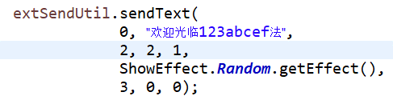
notice | Time-consuming operation, please call in the worker thread, and get the call result OnTcpNetWorkListener.onStatus in the set listener

sendText(Expanded library, new V1.4.0)
boolean sendText( int nWndNo,
String content, int crColor,
int nFontSize, int nSpeed, int nEffect,
int nStayTime, int nAlignmentHori, int nAlignmentVert, boolean isExt)
Use | Sends formatted text (ASCII) to the specified window
Params | nWndNo: Sequence number of window, virtual value 0-7.  Content: text string.  crColor: value 1-7 for color: red, green, yellow, blue, purple, skyblue and white.  nFontSize: value 0-7 for size: 8, 12, 16, 24,32, 40, 48, 56  nSpeed: value 1 ~ 100. The smaller the value, the faster the speed.  nEffect: Display effect coding  nStayTime: The unit is seconds.  nAlignmentHori: Horizontal alignment (0: left alignment, 1: horizontal middle, 2: right alignment)  nAlignmentVert: Vertical alignment (0: top alignment, 1: vertical middle, 2: bottom alignment)  isExt: ASCII(default true)  The corresponding lmf font file must be on the card
Return | True: successfully，false otherwise.
example
notice | Perform time-consuming operations in the worker thread and obtain the call result OnTcpNetWorkListener.onStatus in the set listener

sendTextRGB (Expanded font color, added V1.4.6)
boolean sendTextRGB( int nWndNo,
String content, byte[] crColors, int nFontSize,
int nSpeed, int nEffect, int nStayTime,
int nAlignmentHori, int nAlignmentVert)
Use | Sends plain text to the specified window
Params | nWndNo: Sequence number of window, virtual value 0-7.  Content: text string.  crColor: value RGB, crColors[0]= color R, crColors[1]= color G, crColors[2]= color B.  nFontSize: value 0-7 for size: 8, 12, 16, 24,32, 40, 48, 56  nSpeed: value 1 ~ 100. The smaller the value, the faster the speed.  nEffect: Display effect coding  nStayTime: The unit is seconds.  nAlignmentHori: Horizontal alignment (0: left alignment, 1: horizontal middle, 2: right alignment)  nAlignmentVert: Vertical alignment (0: top alignment, 1: vertical middle, 2: bottom alignment)
Return | True: successfully，false otherwise.
example
notice | Perform time-consuming operations in the worker thread and obtain the call result OnTcpNetWorkListener.onStatus in the set listener

sendPicture
boolean sendPicture(int nWndNo,
int nSpeed, int nEffect,
int nStayTime, String picturePath)
Use | Send pictures to the specified window, which can be gif, jpg, or png pictures
Params | nWndNo: Sequence number of window, virtual value 0-31.  nSpeed: value 1 ~ 100. The smaller the value, the faster the speed.  nEffect: display effect code  nStayTime: The unit is seconds.  picturePath: absolute path of picture file. Include gif, jpg, png.
Return | True: successfully，false otherwise.
example | 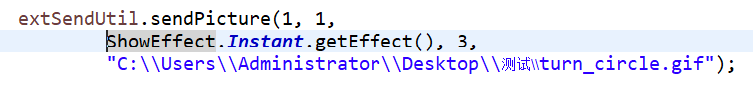
notice | Time-consuming operation, please call in the worker thread, and get the call result OnTcpNetWorkListener.onStatus in the set listener

sendPictureWithScale
boolean sendPicture(int nWndNo, int winWidth, int winHeight,
int nSpeed, int nEffect, int scaleType,
int nStayTime, String picturePath)
Use | Send pictures to the specified window, which can be jpg or png pictures. And the scaleType can be selected
Params | nWndNo: Sequence number of window, virtual value 0-31.  winWidth: width of window  winHeight: height of window  nSpeed: value 1 ~ 100. The smaller the value, the faster the speed.  Ineffect: display effect code  ScaleType: image scaling method coding  nStayTime: The unit is seconds.  picturePath: absolute path of picture file. Include gif, jpg, png.
Return | True: successfully，false otherwise.
example | 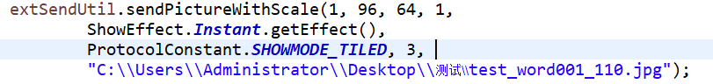
notice | Time-consuming operation, please call in the worker thread, and get the call result OnTcpNetWorkListener.onStatus in the set listener

sendVideo
boolean sendVideo (int nWndNo ,String videoPath)
Use | Send video to specified window.
Params | nWndNo: Sequence number of window, virtual value 0-31. picturePath: absolute path of video file.
Return | True: successfully，false otherwise.
example
notice | Time-consuming operation, please call in the worker thread, and get the call result OnTcpNetWorkListener.onStatus in the set listener

saveSentDataToFlash
boolean saveSentDataToFlash()
Use | Save split screen information and programs which sent by sendText and sendPicture. If not call this, the sent data will not be saved when control card restart.
Params
Return | True: successfully，false otherwise.
notice | Time-consuming operation, please call in the worker thread, and get the call result OnTcpNetWorkListener.onStatus in the set listener

clearSavedDataFromFlash
boolean clearSavedDataFromFlash()
Use | Clear Save split screen information and programs which sent by sendText and sendPicture. And the sent data will not be saved when control card restart.
Params
Return | True: successfully，false otherwise.
notice | Time-consuming operation, please call in the worker thread, and get the call result OnTcpNetWorkListener.onStatus in the set listener

getBrightness
int[] getBrightness()
Use | Get the current brightness value, with 24 values ranging from 00: 00 to 24: 00. The value range is 0-31, and -1 indicates photosensitive control.
Params
Return | The brightness value, length is 24, represent 24 time slot from 00:00.
notice | This method is time-consuming, you can call it in work thread to avoid blocking of main thread, and monitor the result int OnTcpNetWorkListener.onStatus

setBrightness
boolean setBrightness(int[] brigghtnessValue)
Use | Set brightness, with 24 values from 00: 00 to 24: 00. The value range is 0-31, and -1 indicates photosensitive control.
Params | brigghtnessValue: The brightness value, length is 24, represent 24 time slot from 00:00. When all 24 value is -1, then is in photosensitivity mode.
Return | True: successfully，false otherwise.
notice | Time-consuming operation, please call in the worker thread, and get the call result OnTcpNetWorkListener.onStatus in the set listener

setScreenOnAndOffTime
boolean setScreenOnAndOffTime(int nHourOn, int nMinuteOn, int nHourOff, int nMinuteOff)
Use | Set the timing switch screen
Params | nHourOn: 0~23  nMinuteOn: 0~59  nHourOff: 0~23  nMinuteOff: 0~59
Return | True: successfully，false otherwise.
notice | Time-consuming operation, please call in the worker thread, and get the call result OnTcpNetWorkListener.onStatus in the set listener

getScreenOnAndOffTime
int[] getScreenOnAndOffTime ()
Use
Params
return | The screen on and off time, length is 4. When value is 255, explain that the switch screen settings are not turned on.
notice | Time-consuming operation, please call in the worker thread, and get the call result OnTcpNetWorkListener.onStatus in the set listener

exitSetScreenOnAndOffTime
boolean exitSetScreenOnAndOffTime ()
Use | Exit screen on and off settings.
Params
Return | True: successfully，false otherwise.
notice | Time-consuming operation, please call in the worker thread, and get the call result OnTcpNetWorkListener.onStatus in the set listener

setScreenSwitch
boolean setScreenSwitch(boolean turnOn)
Use | Open and close the screen immediately (the restart card fails)
Params | TurnOn: true means on, false means off
Return | True: successfully，false otherwise.
notice | Time-consuming operation, please call in the worker thread, and get the call result OnTcpNetWorkListener.onStatus in the set listener

quitExternalScreen
boolean quitExternalScreen()
Use | Exit the multi-window program mode and return to the regular program playing
Params
Return | True: successfully，false otherwise.
notice | Time-consuming operation, please call in the worker thread, and get the call result OnTcpNetWorkListener.onStatus in the set listener

Selectplayprogram (added in v1.3.2)
Boolean selectPlayProgram (boolean save, byte[] programIndex)
function | Selective broadcasting program
parameter | Save: save or not. After saving, the power-off restart is still valid  ProgramIndex: an array of program numbers to be broadcast, starting from 1
Return value | True: successfully，false otherwise.
Other instructions | Time-consuming operation, please call in the worker thread, and get the call result OnTcpNetWorkListener.onStatus in the set listener

Exitselectplay (added in v1.3.2)
boolean exitSelectPlay ()
function | Exit the selective broadcasting mode and return to normal broadcasting
parameter | without
Return value | True: successfully，false otherwise.
Other instructions | Time-consuming operation, please call in the worker thread, and get the call result OnTcpNetWorkListener.onStatus in the set listener

Setvariablevalue (added in v1.3.2)
boolean setVariableValue (boolean saveToFlash, int variableNum, byte[]... datas)
Use | Set variable value
Params | saveToFlash: Whether to save  variableNum: Number of variables  datas :variable value, two-dimensional byte array  For example, set two variable values: (V1.4.5 added this description)[  [0x01,0xaa,0xbb,0xcc],  [0x02,0xaa,0xbb,0xcc]  ]  0x01: Indicates the serial number of the variable, the first variable  0x02: Indicates the serial number of the variable, the second variable  0xaa,0xbb,0xcc: Byte values representing variable content, text content
Return | True: successfully，false otherwise.
notice | Time-consuming operation, please call in the worker thread, and get the call result OnTcpNetWorkListener.onStatus in the set listener

readyToUseProgramTemplate（V1.3.7 added）
Void readyToUseProgramTemplate(int screenWidth, int screenHeight)
Use | Ready to enter Program Template Mode
Params | screenWidth  screenHeight
Return
notice | Time-consuming operation, please call in the worker thread, and get the call result OnTcpNetWorkListener.onStatus in the set listener

sendTemplateProgram（V1.3.7 added）
Void sendTemplateProgram(int programNo, List<WindowAttr> windows, boolean showImmediately)
Use | Send template programs, support Text, Image, Temperature
Params | programNo: program number  windows : Window attributes and program parameters  WindowAttr：  Window：startX, startY, width, height  Program：  TextItem Text  ImageItem Image  TempHumiItem temperature or humidity  showImmediately: Whether to show the show immediately
Return
notice | Time-consuming operation, please call in the worker thread, and get the call result OnTcpNetWorkListener.onStatus in the set listener. And  OnTcpNetWorkListener.onTcpProcess to Monitor sending progress

deleteTemplateProgram（V1.3.7 added）
Void deleteTemplateProgram(int... programNos)
Use | Delete the program of the specified number
Params | programNos: Program number, support multiple
Return
notice | Time-consuming operation, please call in the worker thread, and get the call result OnTcpNetWorkListener.onStatus in the set listener

enterOrExitTemplateProgramMode（V1.3.7 added）
Void enterOrExitTemplateProgramMode(boolean enter)
Use | Enter or exit Program Template Mode
Params | Enter: true - enter，false - exit
Return
notice | Time-consuming operation, please call in the worker thread, and get the call result OnTcpNetWorkListener.onStatus in the set listener

setReceiveTimeout（Added in V1.4.0）
setReceiveTimeout(int timeout);
Use | Set the timeout period for receiving returned packet data
Params | timeout: Indicates the timeout period, expressed in milliseconds. The default value is 5000 milliseconds.

getReceiveTimeout（Added in V1.4.0）
getReceiveTimeout ();
Use | Gets the timeout period for receiving returned packet data
Params

createGlobalAreaWindow（Added in V1.4.4）
boolean createGlobalAreaWindow(boolean saveToFlash, List<AreaWindowPojo> dataList)
Use | Create a global area window
Params | saveToFlash: indicates whether to save the data to flash. 0: no, 1: yes.  dataList: AreaWindowPojo, the List length must be 1 or 2.  View AreaWindowPojo objects:  int windowType = 1; //Window type, default 1: is a text type  int showType ; //Display mode, Bit 0 to 1: Align left and right  0 justified left, 1 centered left and right, 2 justified right  Bit 2 to 3: Alignment up and down  0 is aligned up, 1 is centered up and down, and 2 is aligned down  int startX; // Window start X wheelbase away  int startY; // Window start Y wheelbase away  int width; // Window width  int height; // Window height  int textColor; // word color， value 1-7 for color: red, green, yellow, blue, purple, skyblue and white.  int textSize; // Text size，value 0-7 for size: 8, 12, 16, 24,32, 40, 48, 56
Return | true: succeeds, false: fails
notice | Perform time-consuming operations in the worker thread

clearAllGlobalArea（Added in V1.4.4）
boolean clearAllGlobalArea()
Use | Clear all global zones
Params | without
Return | true: succeeds, false: fails
notice | Perform time-consuming operations in the worker thread

setIO（Added in V1.4.4）
boolean setIO(byte io1,byte io2,byte io3,byte io4,byte io5)
Use | Set the high and low levels of the five I/O ports
Params | io1: indicates the I/O port of route 1  io2: indicates the I/O port of route 2  io3: indicates the third I/O port  io4: indicates the I/O port of route 4  io5: indicates the I/O port of route 5  0x81: High, 0x80: low, 0x00 or 0x01: invalid
Return | true: succeeds, false: fails
notice | Perform time-consuming operations in the worker thread

setTextComplex（Added in V1.4.5）
void setTextComplex (int textComplex)
作用 | Sets whether the text in the program is in traditional Chinese
参数 | textComplex: indicates whether the text is traditional, 0: no, 1: traditional
返回值
其它说明

getTextComplex（Added in V1.4.5）
int getTextComplex ()
作用 | Check whether the text in the text program is in traditional Chinese
参数
返回值 | textComplex: indicates whether the text is traditional, 0: no, 1: traditional
其它说明

OnTcpNetWorkListener

onSocketInit
onSocketInit(int result);
Use | Monitor socket connect status
Params | Result: 0 fail,1 success

onStatus
onStatus(int status, int socketindex);
Use | Monitor data send status
Params | Status: -1 means error occur , 1 means ok.  Socketindex: socket Index

onBackBytes
onBackBytes(int[] backbytes, int socketindex);
Use
Params | Backbytes: back data from control card  Socketindex：socket Index

onTcpProcess
onTcpProcess(int process, int totalprocess, int socketindex);
Use | Monitor data send progress when send picture or other files
Params | Process：  Totalprocess：  Socketindex：socket Index

breakSocket
breakSocket(int socketindex);
Use | Monitor socket closed.
Params | Socketindex: socket Index

Multi-window Protocol (Serial port) (added in V1.3.4)

com.lumen.ledcenter3.protocol.ExtSendUtil_COM
Program delivery process:
1. Call initCOM to initialize network communication parameters
2. Call setListener to set the listener and monitor the communication status
(Please make the following interface call in the worker thread)
3. Call splitScreen to split Windows
4. Call sendXXX to send the program

com.lumen.ledcenter3.protocol.ExtSendUtil_COM.OnCOMListener

Call example
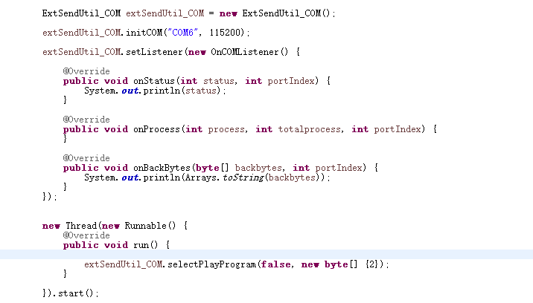

4.1. Overview

3.1 Overview of Key Management Interface
CypherManager

serial number | API interface function name | Interface description | completeness
one | setSecretKey | Set the control card communication key | Achieved

3.2,Details of Key Management Interface

setSecretKey
void setSecretKey (String secretKey)
function | Set the control card communication key
parameter | SecretKey: key
Return value | without
Other instructions | 1、Please call this method before communicating with the control card  2、Password length must be 8, which can be a mixture of numbers and letters

4,Control (added in V1.3.0)
com.lumen.ledcenter3.protocol.ControlUtil
com.lumen.ledcenter3.protocol. ControlUtil.OnControlListener

4.1,Overview
ExtSendUtil_COM
 | Name | Description
1 | initCOM | Example Initialize serial port connection parameters
2 | setListener | Set up the network communication monitor
3 | splitScreen | split window
4 | sendText | Send text
5 | sendPicture | Send pictures (including jpg.png.gif)
6 | sendPictureWithScale | Send pictures, zoom can be set (gif not supported)
7 | saveSentDataToFlash | Save the sent program
8 | clearSavedDataFromFlash | Do not save sent programs (will be cleared after restart)
9 | getBrightness | Get brightness
10 | setBrightness | set brightness
11 | setScreenOnAndOffTime | Set the switch screen time
12 | getScreenOnAndOffTime | Gets the switch screen time
13 | exitSetScreenOnAndOffTime | No automatic switch screen
14 | setScreenSwitch | Immediate switch panel
15 | quitExternalScreen | Exit the multi-window program
16 | selectPlayProgram | Selected program
17 | exitSelectPlay | Exit the program
18 | setVariableValue | Set variable value
20 | createGlobalAreaWindow | Create a global area window
21 | clearAllGlobalArea | Know all global areas
22 | setTextComplex | Set the text in the text program to traditional Chinese
23 | getTextComplex | Gets whether the text in the text program is in traditional Chinese

OnCOMListener
No | Name | Description
1 | onStatus | Communication status
2 | onBackBytes | Returned data
3 | onProcess | Upload progress (when sending pictures or files)

4.2、Detail description

initCOM
initCOM (String portName, int baudrate)
Use | Example Initialize network parameters
Params | portName  baudrate

setListener
setListener (OnCOMListener listener)
Use | Set up a communication monitor
Params | Listener: Serial communication monitor

splitScreen
boolean splitScreen(int windowCount, int[]... winRects)
Use | Divided into Windows, maximum 8. If you want to save the program to the flash memory (savesentdata atoflash), you must call.
Params | windowCount: The number of windows to be split, and within the limits of 1 to 8.  winRects：array of windows’s rects.  winRect is The coordinates of a window. Each window uses four integers to represent its coordinate values of "left, top, right and bottom"
Return | True: successfully，false otherwise.
example
notice | Perform time-consuming operations in the worker thread and obtain the call result in the set listener

sendText
boolean sendText( int nWndNo,
String content, int crColor,
int nFontSize, int nSpeed, int nEffect,
int nStayTime, int nAlignmentHori, int nAlignmentVert)
Use | Sends formatted text to the specified window
Params | nWndNo: Sequence number of window, virtual value 0-7.  Content: text string.  crColor: value 1-7 for color: red, green, yellow, blue, purple, skyblue and white.  nFontSize: value 0-7 for size: 8, 12, 16, 24,32, 40, 48, 56  nSpeed: value 1 ~ 100. The smaller the value, the faster the speed.  nEffect: Display effect coding  nStayTime: The unit is seconds.  nAlignmentHori: Horizontal alignment (0: left alignment, 1: horizontal middle, 2: right alignment)  nAlignmentVert: Vertical alignment (0: top alignment, 1: vertical middle, 2: bottom alignment)
Return | True: successfully，false otherwise.
example | 
notice | Perform time-consuming operations in the worker thread and obtain the call result in the set listener

sendPicture
boolean sendPicture(int nWndNo,
int nSpeed, int nEffect,
int nStayTime, String picturePath)
Use | Send an image to the specified window, which can be a gif, jpg, or png image
Params | nWndNo: Sequence number of window, virtual value 0-7.  nSpeed: value 1 ~ 100. The smaller the value, the faster the speed.  nEffect:Display effect coding  nStayTime: The unit is seconds.  picturePath: absolute path of picture file. Include gif, jpg, png.
Return | True: successfully，false otherwise.
example | 
notice | Perform time-consuming operations in the worker thread and obtain the call result in the set listener

sendPictureWithScale
boolean sendPicture(int nWndNo, int winWidth, int winHeight,
int nSpeed, int nEffect, int scaleType,
int nStayTime, String picturePath)
Use | Send the image to the specified window. It can be a jpg or png image. And you can choose the scaleType.
Params | nWndNo: Sequence number of window, virtual value 0-7.  winWidth: width of window  winHeight: height of window  nSpeed: value 1 ~ 100. The smaller the value, the faster the speed.  nEffect: Display effect coding  scaleType: Image scaling mode encoding  nStayTime: The unit is seconds.  picturePath: absolute path of picture file. Include gif, jpg, png.
Return | True: successfully，false otherwise.
example | 
notice | Perform time-consuming operations in the worker thread and obtain the call result in the set listener

saveSentDataToFlash
boolean saveSentDataToFlash()
Use | Save split screen information and programs which sent by sendText and sendPicture. If not call this, the sent data will not be saved when control card restart.
Params
Return | True: successfully，false otherwise.
notice | Perform time-consuming operations in the worker thread and obtain the call result in the set listener

clearSavedDataFromFlash
boolean clearSavedDataFromFlash()
Use | Clear Save split screen information and programs which sent by sendText and sendPicture. And the sent data will not be saved when control card restart.
Params
Return | True: successfully，false otherwise.
notice | Perform time-consuming operations in the worker thread and obtain the call result in the set listener

getBrightness
int[] getBrightness()
Use | Gets the current brightness value, 24 values from 00:00 to 24:00. Value range 0-31, -1 indicates light sensitive control.
Params
Return | The brightness value, length is 24, represent 24 time slot from 00:00.
notice | This method is time-consuming, you can call it in work thread to avoid blocking of main thread, and monitor the result int

setBrightness
boolean setBrightness(int[] brigghtnessValue)
Use | Set brightness, 24 values from 00:00 to 24:00. Value range 0-31, -1 indicates light sensitive control.
Params | brigghtnessValue: The brightness value, length is 24, represent 24 time slot from 00:00. When all 24 value is -1, then is in photosensitivity mode.
Return | True: successfully，false otherwise.
notice | Perform time-consuming operations in the worker thread and obtain the call result in the set listener

setScreenOnAndOffTime
boolean setScreenOnAndOffTime(int nHourOn, int nMinuteOn, int nHourOff, int nMinuteOff)
Use | Set the timing switch panel
Params | nHourOn: 0~23  nMinuteOn: 0~59  nHourOff: 0~23  nMinuteOff: 0~59
Return | True: successfully，false otherwise.
notice | Perform time-consuming operations in the worker thread and obtain the call result in the set listener

getScreenOnAndOffTime
int[] getScreenOnAndOffTime ()
Use
Params
return | The screen on and off time, length is 4. When value is 255, explain that the switch screen settings are not turned on.
notice | Perform time-consuming operations in the worker thread and obtain the call result in the set listener

exitSetScreenOnAndOffTime
boolean exitSetScreenOnAndOffTime ()
Use | Exit screen on and off settings.
Params
Return | True: successfully，false otherwise.
notice | Perform time-consuming operations in the worker thread and obtain the call result in the set listener

setScreenSwitch
boolean setScreenSwitch(boolean turnOn)
Use | Switch the screen immediately (restart card fails)
Params | TurnOn: true indicates on, false indicates off
Return | True: successfully，false otherwise.
notice | Perform time-consuming operations in the worker thread and obtain the call result in the set listener

quitExternalScreen
boolean quitExternalScreen()
Use | Exit multi-window program mode and return to regular program playback
Params
Return | True: successfully，false otherwise.
notice | Perform time-consuming operations in the worker thread and obtain the call result in the set listener

selectPlayProgram
boolean selectPlayProgram (boolean save, byte[] programIndex)
Use | Selected program
Params | save: Whether to save. After saving, power off restart still works  programIndex: An array of program numbers to broadcast, starting with 1
Return | True: successfully，false otherwise.
notice | Perform time-consuming operations in the worker thread and obtain the call result in the set listener

exitSelectPlay
boolean exitSelectPlay ()
function | Exit the program mode and return to normal playback
Params | 无
Return | True: successfully，false otherwise.
notice | Perform time-consuming operations in the worker thread and obtain the call result in the set listener

setVariableValue
boolean setVariableValue (boolean saveToFlash, int variableNum, byte[]... datas)
Use | Set variable value
Params | saveToFlash: Whether to save  variableNum: Number of variables  datas :variable value, two-dimensional byte array  For example, set two variable values: (V1.4.5 added this description)[  [0x01,0xaa,0xbb,0xcc],  [0x02,0xaa,0xbb,0xcc]  ]  0x01: Indicates the serial number of the variable, the first variable  0x02: Indicates the serial number of the variable, the second variable  0xaa,0xbb,0xcc: Byte values representing variable content, text content
Return | True: successfully，false otherwise.
notice | Perform time-consuming operations in the worker thread and obtain the call result in the set listener

createGlobalAreaWindow（Added in V1.4.4）
boolean createGlobalAreaWindow(boolean saveToFlash, List<AreaWindowPojo> dataList)
Use | Create a global area window
Params | saveToFlash: indicates whether to save the data to flash. 0: no, 1: yes.  dataList: AreaWindowPojo, the List length must be 1 or 2.  View AreaWindowPojo objects:  int windowType = 1; //Window type, default 1: is a text type  int showType ; //Display mode, Bit 0 to 1: Align left and right  0 justified left, 1 centered left and right, 2 justified right  Bit 2 to 3: Alignment up and down  0 is aligned up, 1 is centered up and down, and 2 is aligned down  int startX; // Window start X wheelbase departure  int startY; // Window start Y wheelbase departure  int width; // window width  int height; // window height  int textColor; // text color， value 1-7 for color: red, green, yellow, blue, purple, skyblue and white.  int textSize; // Text size，value 0-7 for size: 8, 12, 16, 24,32, 40, 48, 56
Return | true: succeeds, false: fails
notice | Perform time-consuming operations in the worker thread

clearAllGlobalArea（Added in V1.4.4）
boolean clearAllGlobalArea()
Use | Clear all global zones
Params | without
Return | true: succeeds, false: fails
notice | Perform time-consuming operations in the worker thread

setTextComplex（Added in V1.4.5）
void setTextComplex (int textComplex)
function | Sets whether the text in the program is in traditional Chinese
params | textComplex: indicates whether the text is traditional, 0: no, 1: traditional
Return
notice

getTextComplex（Added in V1.4.5）
int getTextComplex ()
function | Check whether the text in the text program is in traditional Chinese
params
return | textComplex: indicates whether the text is traditional, 0: no, 1: traditional
notice

getSendTextData（Added in V1.4.7）
boolean getSendTextData(int nWndNo,
String content, int crColor,
int nFontSize, int nSpeed, int nEffect,
int nStayTime, int nAlignmentHori, int nAlignmentVert)
Use | Get send data (send formatted text to specified window)
Params | nWndNo: Sequence number of window, virtual value 0-7.  Content: text string.  crColor: value 1-7 for color: red, green, yellow, blue, purple, skyblue and white.  nFontSize: value 0-7 for size: 8, 12, 16, 24,32, 40, 48, 56  nSpeed: value 1 ~ 100. The smaller the value, the faster the speed.  nEffect: Display effect coding  nStayTime: The unit is seconds.  nAlignmentHori: Horizontal alignment (0: left alignment, 1: horizontal middle, 2: right alignment)  nAlignmentVert: Vertical alignment (0: top alignment, 1: vertical middle, 2: bottom alignment)
Return | True: successfully，false otherwise.
example | 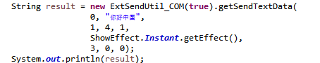
notice | The initCOM interface method is not required

OnCOMListener

onStatus
onStatus(int status, int portIndex);
Use | Monitor data send status
Params | Status: -1 means error occur , 1 means ok.  portIndex: Port Number identification (Custom)

onBackBytes
onBackBytes(int[] backbytes, int portIndex);
Use
Params | Backbytes: back data from control card  portIndex: Port Number identification (Custom)

onProcess
onProcess(int process, int totalprocess, int portIndex);
Use | Monitor data send progress when send picture or other files
Params | Process：  Totalprocess：  portIndex: Port Number identification (Custom)

5、Control (network)（Added in V1.3.0）
com.lumen.ledcenter3.protocol.ControlUtil
com.lumen.ledcenter3.protocol. ControlUtil.OnControlListener

Call example
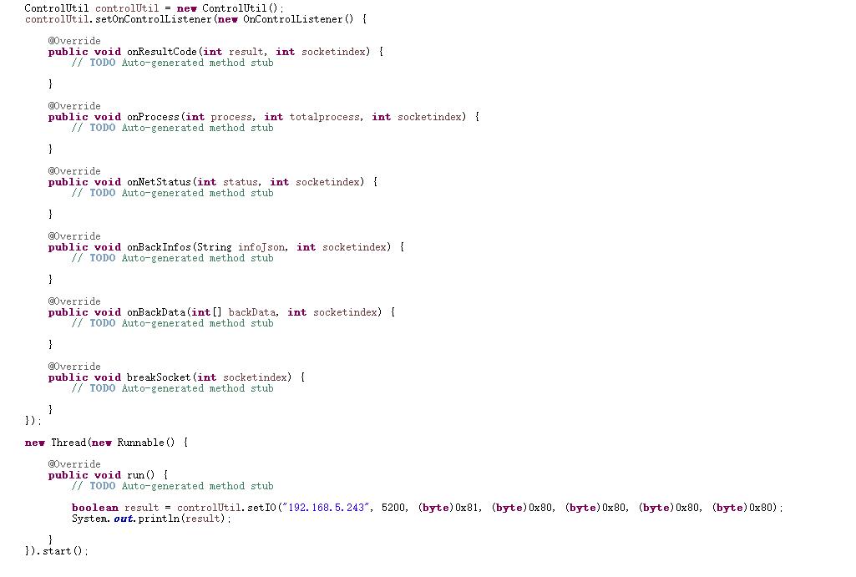

5.1、overview
ControlUtil
serial number | API interface function name | Interface description
1 | setOnControlListener | Set listener
2 | getCurrentPlayProgramNo | Acquiring the program number and the total number of programs currently played
3 | getCurrentProgramScreenshot | Get a screenshot of the currently playing program
4 | getCurrentPlayProgramContent | Gets the text content of window 1 of the program number
5 | getMultiWindowsData | Gets the latest multi-window protocol sendtext content
6 | selectPlayProgram | Selected program
7 | exitSelectPlay | Exit the program
8 | getProgramFileInfos | Gets a list of sent program files
9 | getUserDiscRemainingSpace | Gets the size of the remaining space in the program area
10 | deleteLpbFile | Deletes the specified program file
11 | formatUserDisk | Formatting user disk
12 | sendInstantMsg | Send instant message
13 | getCurrentCardTimeDate | Obtain the current time of the controller card
14 | setCardTimeDateToNow | Set the controller card time to the current time
15 | setCardTimeDate | Set the control card time manually
16 | restartApp | Restart the App
17 | restartHard | Restart hardware
18 | getGlobalVariable | Gets the value of a global variable
19 | setIO | Set the high and low levels of the five I/O ports
20 | setTextComplex | Set the text in the text program to traditional Chinese
21 | getTextComplex | Gets whether the text in the text program is in traditional Chinese

OnControlListener
serial number | API interface function name | Interface description
1 | onStatus | Listen for connection status
2 | onProcess | Monitor the progress of sending (receiving) data
3 | onBackInfos | Listen for the returned information (string)
4 | breakSocket | The listening connection is broken
5 | onBackData（V1.3.2） | Information returned by listening (array)
6 | onResultCode | Task execution state
7 | onNetStatus | Receiving network communication status (whether communication is successful)

5.2,Interface Details
1、ControlUtil

setOnControlListener
void setListener (OnControlListener listener)
function | Set listener
parameter | Listener: Listener object
Return value | without
Other instructions

Getcurrentplayprogramno (modified by v1.3.2)
void getCurrentPlayProgramNo (String cardIp, int port)
function | Get the program number and total number of programs currently played (V1.3.0)  Get the current broadcast type, total number of programs and the current broadcast program number (V1.3.2)
parameter | CardIP: IP address of control card  Port: port
Return value | without
Other instructions | Get the value in onBackInfos of OnControlListener (V1.3.0)  Get the value (V1.3.2) from onbackdata (int [] backdata, int socket index) of OnControlListener:  There are three values in backData, namely, playing type, total number of programs and currently playing program number.  The play types are as follows:  0 general programs;  1 selective broadcasting programs;  2 Play the program specified in the schedule;  3 selective broadcasting program (trigger the small board selective broadcasting)

getCurrentProgramScreenshot
void getCurrentProgramScreenshot (String cardIp, int port，String screenshotFileDir)
function | Get a screenshot of the current screen
parameter | CardIP: IP address of control card  Port: port  ScreenshotFileDir: screenshot saving directory
Return value | without
Other instructions | In the onProcess of OnControlListener, you can monitor the progress of obtaining the screenshot  1.4.3 Update (Added a listening event that returns the control card IP address) :  controlUtil.setOnControlListenerNew(new OnControlListenerNew() {  @Override  public void onProcessWithIp(String ip, int process, int totalprocess, int socketindex) {  // TODO Auto-generated method stub  System.out.println(ip);  System.out.println(process+"---"+totalprocess);  }  });

getCurrentPlayProgramContent（Added in V1.4.2）
void getCurrentPlayProgramContent (String cardIp, int port, int programNo)
function | Gets the text content of window 1 of the program number
params | cardIP: IP address of the controller card  port: port  programNo: Program number, 0: current program, 1: first program, 2: second program
return | without
Other instructions | Obtain the value from onBackInfos in OnControlListener
void getCurrentPlayProgramContent (String cardIp, int port, int programNo, int receiveTimeout)
function | Get the program content of the program number
params | cardIP: IP address of the controller card  port: port  programNo: Program number, 0: current program, 1: first program, 2: second program  receiveTimeout: indicates the receiving timeout period
return | without
Other instructions | Obtain the value from onBackInfos in OnControlListener

getMultiWindowsData（Added in V1.4.2）
void getMultiWindowsData (String cardIP, int port)
Function | Gets the latest multi-window protocol sendtext content
Params | cardIP: IP address of the controller card  port; port
Return | Without
Other instructions | Obtain the value from onBackInfos in OnControlListener  Return data for example:  Success: {"size":2, "color":1, "content": a b c d e,}  Failed: Additional information  size: Text size, value 0-7 for size: 8, 12, 16, 24,32, 40, 48, 56  value 1-7 for color: red, green, yellow, blue, purple, skyblue and white.  content: indicates the text content

Selectplayprogram (added in v1.3.2)
void selectPlayProgram (String cardIp, int port，boolean save, byte[] programIndex)
function | Selective broadcasting program
parameter | CardIP: IP address of control card  Port: port  Save: save or not. After saving, the power-off restart is still valid  ProgramIndex: an array of program numbers to be broadcast, starting from 1
Return value | without
Other instructions | OnStatus in OnControlListener monitors whether the call is successful.

Exitselectplay (added in v1.3.2)
void exitSelectPlay (String cardIp, int port)
function | Exit the selective broadcasting mode and return to normal broadcasting
parameter | CardIP: IP address of control card  Port: port
Return value | without
Other instructions | OnStatus in OnControlListener monitors whether the call is successful.

Getprogramfileinfos (added in v1.3.3)
List<LpbFileInfo> getProgramFileInfos (String cardIp, int port)
function | Get the list of sent program files
parameter | CardIP: IP address of control card  Port: port
Return value | List of program files
Other instructions | LpbFileInfo includes program file name and file size

Getuserdiscremainspace (added in v1.3.3)
long getUserDiscRemainingSpace (String cardIp, int port)
function | Acquire that remaining space size of the program area
parameter | CardIP: IP address of control card  Port: port
Return value | Size of remaining space in program area
Other instructions

Deletelpbfile (added in v1.3.3)
boolean deleteLpbFile (String cardIp, int port, String LpbFileNameWithSuffix)
function | Delete the specified program file
parameter | CardIP: IP address of control card  Port: port  LpbFileNameWithSuffix: the program file name is xxx.lpb
Return value | True indicates that the deletion was successful, otherwise false is returned
Other instructions

Formatuserdisk (added in v1.3.4)
True formatUserDisk(
String cardIp, int port, int protocolModel, String deviceMac)
function | Format user disk (area)
parameter | cardIP: IP address of the controller card  port: port  deviceMac (Optional) : unique Mac address of a device  protocolModel (Optional) : indicates a protocol type of 0:auto, 1:old, and 2:new
Return value | True indicates successful formatting, otherwise false is returned
Other instructions

Sendinstantmsg (added in v1.3.5)
True sendInstantMsg(String cardIP, int port, int startX, int startY, int nWidth, int nHeight,
int playCount, String content, int crColor,
int nFontSize, int nSpeed,
int nStayTime, boolean scroll)
function | Send timely information
parameter | cardIP: IP address of the controller card  port：port  startX : X starting position  startY : Y starting position  nWidth : width  nHeight: height  playCount: times of play  Content:information content  crColor value 1-7 for color: red, green, yellow, blue, purple, skyblue and white.  nFontSize Font size value 0-7 for size: 8, 12, 16, 24,32, 40, 48, 56  nSpeed Playback speed ranges from 100 to 0  nStayTime Residence time  scroll Whether to scroll (scroll left, text centered)
Return value
Other instructions

Getcurrentcardtimedate (added in v1.3.6)
void getCurrentCardTimeDate(String cardIp, int port)
function | Get the current time of the control card in the format of {"year", "month", "day", "hour", "minute", "second"}
parameter | CardIP: IP address of control card  Port: port
Return value | without
Other instructions | OnBackInfos in OnControlListener listens for the returned results.

Setcardtimedatetonow (added in v1.3.6)
void setCardTimeDateToNow(String cardIp, int port)
function | Set the control card time as the current time
parameter | CardIP: IP address of control card  Port: port
Return value | without
Other instructions | OnResultCode in OnControlListener listens for the returned result.

Setcardtimedate (added in v1.3.6)
void setCardTimeDate(String cardIp, int port, int year, int month, int day, int hour, int minute, int second, int week)
function | Set the control card time and set it manually.
parameter | CardIP: IP address of control card  Port: port  Year:  Month:  Day:  Hour:  Minute:  Second:  Week:
Return value | without
Other instructions | OnResultCode in OnControlListener listens for the returned result.

restartApp（V1.4.3新增）
boolean restartApp(String cardIp, int port)
function | Restart the APP
params | cardIP: IP address of the controller card  port：port
return | true表示重启成功，否则返回false
Other instructions

restartHard（Added in V1.4.3）
boolean restartHard(String cardIp, int port)
function | Restart hardware
params | cardIP: IP address of the controller card  port: port
return | true: The restart succeeds. Otherwise, false is returned
Other instruction

3、OnControlLisenter

getGlobalVariable（Added in V1.4.3）
void getGlobalVariable (String cardIp, int port, byte[] variableNum)
function | Gets the value of a global variable
params | cardIp: IP address of the controller card  port; port  variableNum: The variable number of each variable, for example, get the values of variables with variable numbers 1 and 2: [0x01,0x02]
return | Without
Other instructions | Obtain the value from onBackInfos in OnControlListener  Return data for example:  Success: {"1":" Value of variable number 1","2":" value of variable number 2"}  Failed: Additional information

setIO（Added in V1.4.4）
boolean setIO(String ip, int port,byte io1,byte io2,byte io3,byte io4,byte io5)
function | Set the high and low levels of the five I/O ports
params | cardIp: IP address of the controller card  port; port  io1: indicates the I/O port of route 1  io2: indicates the I/O port of route 2  io3: indicates the third I/O port  io4: indicates the I/O port of route 4  io5: indicates the I/O port of route 5  (0x81: High, 0x80: low, 0x00 or 0x01: invalid)
return | true: succeeds, false: fails
Other instructions

getCardMacAndPort（Added in V1.4.7）
void getCardMacAndPort(String ip)
function | Gets the MAC address and port of the control card
params | cardIp: IP address of the controller card
return | Without
Other instructions | Obtain the value from onBackInfos in OnControlListener  Return data for example:  Success: {"MAC": value, "Port": value}  Failed: Additional information

setTextComplex（Added in V1.4.5）
void setTextComplex (int textComplex)
function | Set whether the text in thn program is in traditional Chinese
params | textComplex: indicates whether the text is traditional, 0: no, 1: traditional
return
Other instructions

getTextComplex（Added in V1.4.5）
int getTextComplex ()
function | Check whether the text in the text program is in traditional Chinese
params
return | textComplex: indicates whether the text is traditional, 0: no, 1: traditional
Other instruction

Onbackdata (added in v1.3.2)
void onBackInfos (int[] backdata, int socketindex)
function | Get the data returned by network communication
parameter | Backdata: returned data information.  Socketindex: request flag, used to distinguish which request returns data
Return value | without
Other instructions

Onbackinfos (modified by v1.3.6)
void onBackInfos (String infoJson, int socketindex)
function | According to socketindex, different infoJson contents are returned  INDEX_PROGRAM_INFO: Get the number and total number of programs currently played  INDEX_GET_CARD_TIME_DATE: get the current card time
parameter | InfoJson: returned data information. Json format string  Socketindex: request flag, used to distinguish which request returns data
Return value | without
Other instructions

Onnet status (modified by v1.3.6)
void onNetStatus (int status, int socketindex)
function | Receive network communication status (whether communication is successful)
parameter | Status: status, 0 failed, 1 succeeded, -1 exception
 | Socketindex; Request flag, used to distinguish which request returns data
Return value | without
Other instructions

onProcess
void onProcess (int process, int totalprocess, int socketindex)
function | File upload (download) progress
parameter | Process: current progress (uploaded data size)  Totalprocess: total progress (total data size)  Socketindex; Request flag, used to distinguish which request returns data
Return value | without
Other instructions

breakSocket
void breakSocket (int socketindex)
function | Receive network disconnection status
parameter | Socketindex; Request flag, used to distinguish which request returns data
Return value | without
Other instructions

On result code (added in v1.3.6)
void onResultCode(int resultCode, int socketindex)
function | Task execution status
parameter | ResultCode: 1: success, 0: failure  Socketindex; Request flag, used to distinguish which request returns data
Return value | without
Other instructions

6、Control (serial port)（Added in V1.3.4）
com.lumen.ledcenter3.protocol. ControlUtil_COM
com.lumen.ledcenter3.protocol. ControlUtil_COM.OnControlListener

Call example
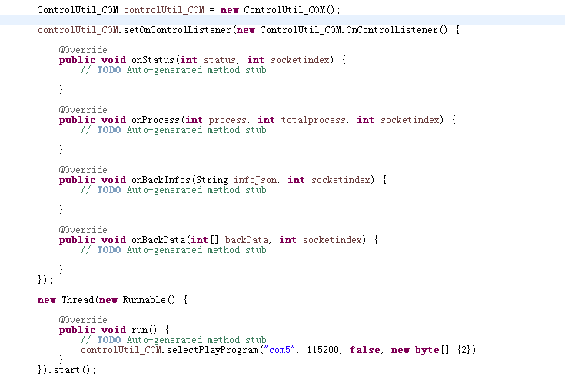

6.1、overview
ControlUtil_COM
serial number | API interface function name | interface specification
1 | setOnControlListener | Set monitor
2 | getCurrentPlayProgramNo | Gets the number and total number of programs currently being played
3 | getCurrentProgramScreenshot | Get a screenshot of the show currently playing
4 | selectPlayProgram | Selected program
5 | exitSelectPlay | Exit the program
6 | getProgramFileInfos | Gets a list of sent program files
7 | getUserDiscRemainingSpace | Gets the size of the remaining space in the program area
8 | deleteLpbFile | Deletes the specified program file
9 | formatUserDisk | Formatting user disk
10 | restartApp | Restart the App
11 | restartHard | Restart hardware

ControlUtil_COM.OnControlListener
serial number | API interface function name | interface specification
1 | onStatus | Monitor connection status
2 | onProcess | Monitor the progress of sending (receiving) data
3 | onBackInfos | Listen for returned information (string)
4 | onBackData（V1.3.2） | Listen for returned information (array)

6.2、Interface Details
1、ControlUtil_COM

setOnControlListener
void setListener (OnControlListener listener)
function | Set monitor
params | listener: indicates the listener
return | Without
Other instructions

getCurrentPlayProgramNo
String getCurrentPlayProgramNo (String portName, int baudrate)
function | Gets the current play type, the total number of programs, and the number of programs currently being played
params | portName: Serial port number of the controller card  baudrate：Baud rate
return | Json string：{playingType: , programSum, programNumber, }
Other instructions | The value of onBackData (int[] backdata, int socketindex) in OnControlListener is obtained:  There are three values in backData, namely the playback type, the total number of programs, and the number of programs currently being played.  The playback type is divided into:  0 general programs;  1 Select broadcast programs;  2 Play programs specified in the schedule;  3 Program selection (trigger board selection)

getCurrentProgramScreenshot
void getCurrentProgramScreenshot (String portName, int baudrate，String screenshotFileDir)
function | Get a screenshot of the current screen
params | portName: Serial port number of the controller card  baudrate：Baud rate  screenshotFileDir：Screenshot save directory
return | Without
Other instructions | In the onProcess of OnControlListener, you can monitor the progress of obtaining the screenshot

selectPlayProgram
void selectPlayProgram (String portName, int baudrate，boolean save, byte[] programIndex)
function | Selected program
params | portName: serial port number of the controller card  baudrate: baudrate save: whether to save. After saving, power off restart still works  save: Whether to save. After saving, power off restart still works  programIndex: An array of program numbers to broadcast, starting with 1
return | without
Other instructions | The onStatus in OnControlListener listens for whether the call was successful.

exitSelectPlay
void exitSelectPlay (String portName, int baudrate)
function | Exit the program mode and return to normal playback
params | portName: serial port number of the controller card  baudrate：Baud rate
return | Without
Other instructions | The onStatus inside OnControlListener listens for success.

getProgramFileInfos
List<LpbFileInfo> getProgramFileInfos (String portName, int baudrate)
function | Gets a list of sent program files
params | portName: serial port number of the controller card  baudrate：baud rate
return | Program file list
Other instructions | LpbFileInfo includes the program filename and file size

getUserDiscRemainingSpace
long getUserDiscRemainingSpace (String portName, int baudrate)
function | Gets the amount of space left in the program area
params | portName: control card serial port  baudrate：baud rate
return | The amount of space left in the program area
Other instructions

deleteLpbFile
boolean deleteLpbFile (String portName, int baudrate, String LpbFileNameWithSuffix)
function | Delete the specified program file
params | portName: control card serial port  baudrate：baud rate  LpbFileNameWithSuffix：program filename for example xxx.lpb
return | True indicates that the deletion was successful; otherwise, false is returned
Other instructions

formatUserDisk
boolean formatUserDisk(String portName, int baudrate)
function | Format the user disk (area)
params | portName: control card serial port  baudrate：baud rate
return | True indicates that the deletion was successful; otherwise, false is returned
Other instructions

restartApp（Added in V1.4.3）
boolean restartApp(String portName, int baudrate)
function | Restart app
params | portName: control card serial port  baudrate：baud rate
return | true: The restart succeeds. Otherwise, false is returned
Other instructions

restartHard（Added in V1.4.3）
boolean restartHard(String portName, int baudrate)
function | Restart hardware
params | portName: control card serial port  baudrate：baud rate
return | True:the restart succeeds，otherwise ,false is returned
Other instructions

2、OnControlLisenter

onBackData
void onBackInfos (int[] backdata, int socketindex)
function | Obtain the data returned by the serial port communication
params | backdata: Returned data information  socketindex：Request flag, used to distinguish which request returned the data
return | Without
Other instructions

onBackInfos
void onBackInfos (String infoJson, int socketindex)
function | Gets the number and total number of programs currently being played
params | infoJson: Returned data information. json format string  socketindex: Request flag, used to distinguish which request returned data
return | Without
Other instructions

onStatus
void onStatus (int status, int socketindex)
function | Receiving network communication status (whether it was successfully sent)
params | status: indicates the status. 0 is failed, 1 is successful, and -1 is abnormal
 | Socketindex; Request flag, used to distinguish which request returned the data
return | Without
Other instructions

onProcess
void onProcess (int process, int totalprocess, int socketindex)
function | File upload (download) progress
params | process: Current progress (size of uploaded data)  totalprocess: Total progress (total data size)  Socketindex; Request flag, used to distinguish which request returned the data
return | 无
Other instructions

7,LMServer (added in v1.3.1)

7.1 Overview of LmServerAPI Interface
serial number | API interface function name | Interface description
1 | LmServer_Login | log in
2 | LmServer_Logout | Exit login
3 | LmServer_LockCard | Lock the control card, called before communicating with the control card
4 | LmServer_UnLockCard | Unlock the control card and call it after the communication of the control card is completed
5 | LmServer_SendPacketData_Net | Send communication data packet to control card (network client)
6 | LmServer_SendPacketData_GPRS | Send communication data packet to control card (GPRS client)
7 | LmServer_SendProgramFiles_Net | Send program package to control card (network client)
 | LmServer_SendProgramFilesAppend_Net | Add and send program package to control card (network client)
8 | LmServer_SendProgramFiles_GPRS | Send program package to control card (GPRS client)
 | LmServer_SendProgramFilesAppend_GPRS | Add and send program package to control card (GPRS client)
9 | LmServer_SendHeartbeatPacket | Occurrence of heartbeat packet
10 | LmServer_RecvCommPacket | Receive data from the server
The following is the specific function interface, the call needs to follow the following steps of the use of this class function. Called in step 3
11 | LmServer_SelectProgram | Selective broadcasting program
12 | LmServer_ExitSelectProgram | Quit the selective broadcast program
13 | LmServer_SetVariableValue | Set variable value
14 | LmServer_GetLpbFileInfos | Get the list of sent program files
15 | LmServer_GetFreeSpace | Acquire that remaining space size of the program area
16 | LmServer_DeleteLpb | Delete the specified program file
17 | getCardDevices | Get all device information
18 | LmServer_GetScreenshot | Gets the current screenshot
19 | getPlayingProgram | Get the number and content of the currently playing program (valid for text programs only)
20 | getProgramContent | Get the playback content of the specified program number (valid for text programs only)
21 | getMultiProgramContent | Get the number and content of all programs (valid for text programs only)
22 | sendSimpleText | Sends formatted text to the specified window
23 | setTextComplex | Set the text in the text program to traditional Chinese characters
24 | getTextComplex | Gets whether the text in the text program is traditional Chinese

Example call

The use steps of this kind of function are as follows:
Step 1: User login
Step 2: Lock the control card
Step 3: Send communication data packet
(Step 4: Receive communication packets) Called as needed
Step 5: Unlock the control card
Step 6: Exit the login

Note: If the user needs to log in online for a long time, it is necessary to send heartbeat packets to the server regularly to maintain the long connection, and the longest interval between heartbeat packets is not more than 120 seconds. The interval time refers to the interval time between the application and LmServer without data exchange.

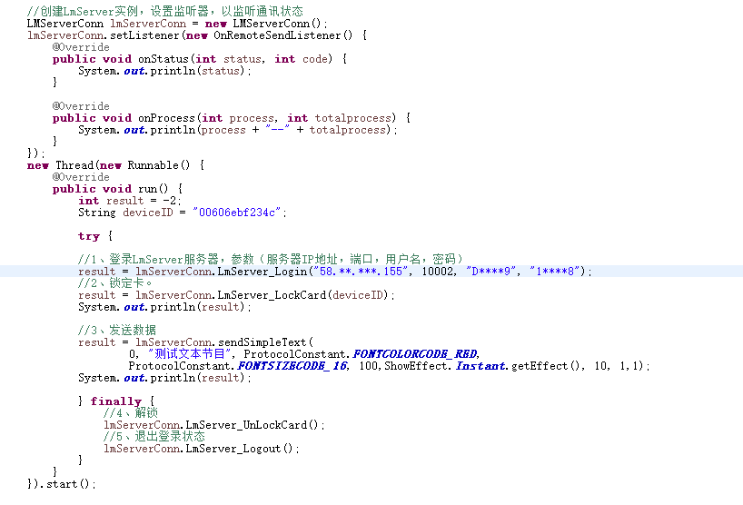

7.2,Detailed description of LmServerAPI interface

LmServer_Login
int LmServer_Login(String ip, int port, String userName, String password);
function | User login
parameter | Ip: IP address of the server, such as "192.168.1.100"
 | Port: server user listening port
 | UserName: user name
 | Password: user password
Return value | -1: communication error  0: login failed  1: login succeeded.  2: User is not registered  3: The user has logged in  4: Wrong password  5: Unable to connect to the server
Other instructions

LmServer_Logout
int LmServer_Logout();
function | User logs out
parameter
Return value
Other instructions

LmServer_LockCard
int LmServer_LockCard( string deviceID );
function | User locking control card
parameter | DeviceID: Control card device ID
Return value | -1: communication error  0: failed  1: success
Other instructions | The user calls this function before communicating with the control card

LmServer_UnLockCard
int LmServer_UnLockCard( string deviceID );
function | User unlock control card
parameter | DeviceID: Control card device ID
Return value | -1: communication error  0: failed  1: success
Other instructions | The user calls this function after the communication with the control card is completed

LmServer_SendPacketData_Net
int LmServer_SendPacketData_Net(String deviceID, byte[] packetData)
function | Send communication data packet to control card (network client)
parameter | StrDeviceID: Control card device ID of communication  PacketData: protocol data, note: "protocol data" is consistent according to the general protocol of our company, and is 0x68 to check code.
Return value | -1: communication error  0: send failed  1: sent, waiting for data to be returned  2: No right to communicate with this control card  3: The control card is not online  4: The control card is currently communicating with other users  5: Send successfully  6: The receiving buffer length is insufficient
Other instructions

LmServer_SendPacketData_GPRS
int LmServer_SendPacketData_GPRS(String deviceID, byte[] packetData)
function | Send communication data packet to control card (GPRS client)
parameter | StrDeviceID: Control card device ID of communication  PacketData: protocol data, note: "protocol data" is consistent according to the general protocol of our company, and is 0x68 to check code.
Return value | -1: communication error  0: send failed  1: sent, waiting for data to be returned  2: No right to communicate with this control card  3: The control card is not online  4: The control card is currently communicating with other users  5: Send successfully  6: The receiving buffer length is insufficient
Other instructions

LmServer_RecvCommPacket
Int[] LmServer_RecvCommPacket();
function | Receive data from the server
parameter
Return value | The received data, if null, means there is no returned data
Other instructions

LmServer_SendProgramFiles_Net
int LmServer_SendProgramFiles_Net(
String deviceID,
String tempDir,
List<String> lpdFilePaths,
int screenWidth,
int screenHeight,
int colorType)
function | Send program package to control card (network client)
parameter | StrDeviceID: Control card device ID of communication  TempDir: directory where temporary files are stored  LpdFilePaths: list of lpd file paths to send  ScreenWidth: screen width. It needs to be consistent with the program file  ScreenHeight: screen height. It needs to be consistent with the program file  ColorType: screen color and gray level. It needs to be consistent with the program file
Return value | -1: communication error  0: send failed  1: sent, waiting for data to be returned  2: No right to communicate with this control card  3: The control card is not online  4: The control card is currently communicating with other users  5: Send successfully  6: The receiving buffer length is insufficient
Other instructions

Lmserver _ sendprogramfilesappend _ net (added in v1.3.3)
int LmServer_SendProgramFilesAppend_Net(
String deviceID,
String tempDir,
List<String> lpdFilePaths,
int screenWidth,
int screenHeight,
int colorType)
function | Send program package to control card (network client)
parameter | StrDeviceID: Control card device ID of communication  TempDir: directory where temporary files are stored  LpdFilePaths: list of lpd file paths to send  ScreenWidth: screen width. It needs to be consistent with the program file  ScreenHeight: screen height. It needs to be consistent with the program file  ColorType: screen color and gray level. It needs to be consistent with the program file
Return value | -1: communication error  0: send failed  1: sent, waiting for data to be returned  2: No right to communicate with this control card  3: The control card is not online  4: The control card is currently communicating with other users  5: Send successfully  6: The receiving buffer length is insufficient
Other instructions

LmServer_SendPacketFiles_GPRS
int LmServer_SendProgramFiles_GPRS(
String deviceID,
String tempDir,
List<String> lpdFilePaths,
int screenWidth,
int screenHeight,
int colorType)
function | Send program package to control card (GPRS client)
parameter | StrDeviceID: Control card device ID of communication  TempDir: directory where temporary files are stored  LpdFilePaths: list of lpd file paths to send  ScreenWidth: screen width. It needs to be consistent with the program file  ScreenHeight: screen height. It needs to be consistent with the program file  ColorType: screen color and gray level. It needs to be consistent with the program file
Return value | -1: communication error  0: send failed  1: sent, waiting for data to be returned  2: No right to communicate with this control card  3: The control card is not online  4: The control card is currently communicating with other users  5: Send successfully  6: The receiving buffer length is insufficient
Other instructions

Lmserver _ sendprogramfilesappend _ GPRS (added in v1.3.3)
int LmServer_SendProgramFilesAppend_GPRS(
String deviceID,
String tempDir,
List<String> lpdFilePaths,
int screenWidth,
int screenHeight,
int colorType)
function | Send program package to control card (GPRS client)
parameter | StrDeviceID: Control card device ID of communication  TempDir: directory where temporary files are stored  LpdFilePaths: list of lpd file paths to send  ScreenWidth: screen width. It needs to be consistent with the program file  ScreenHeight: screen height. It needs to be consistent with the program file  ColorType: screen color and gray level. It needs to be consistent with the program file
Return value | -1: communication error  0: send failed  1: sent, waiting for data to be returned  2: No right to communicate with this control card  3: The control card is not online  4: The control card is currently communicating with other users  5: Send successfully  6: The receiving buffer length is insufficient
Other instructions

LmServer_SendHeartbeatPacket
int LmServer_SendHeartbeatPacket ();
function | Send heartbeat packet
parameter
Return value | 1: success  0: failed  -1: communication error
Other instructions | The maximum interval between heartbeat packet is no more than 120 seconds

Lmserver _ select program (added in v1.3.2)
int LmServer_SelectProgram(String deviceID, boolean save, byte[] programIndex)
function | Selective broadcasting program
parameter | StrDeviceID: Control card device ID of communication  Save: save or not. After saving, the power-off restart is still valid  ProgramIndex: an array of program numbers to be broadcast, starting from 1
Return value | -1: communication error  0: send failed  1: sent, waiting for data to be returned  2: No right to communicate with this control card  3: The control card is not online  4: The control card is currently communicating with other users  5: Send successfully  6: The receiving buffer length is insufficient
Other instructions

Lmserver _ exitselectprogram (added in v1.3.2)
int LmServer_ ExitSelectProgram (String deviceID)
function | Quit the selective broadcast program
parameter | StrDeviceID: Control card device ID of communication
Return value | -1: communication error  0: send failed  1: sent, waiting for data to be returned  2: No right to communicate with this control card  3: The control card is not online  4: The control card is currently communicating with other users  5: Send successfully  6: The receiving buffer length is insufficient
Other instructions

Lmserver _ setvariablevalue (added in v1.3.2)
int LmServer_ SetVariableValue (String deviceID, boolean saveToFlash, int variableNum, byte[]... datas)
function | Set variable value
parameter | StrDeviceID: Control card device ID of communication  Save saveToFlash?  Number of variableNum variables  Datas variable value
Return value | -1: communication error  0: send failed  1: sent, waiting for data to be returned  2: No right to communicate with this control card  3: The control card is not online  4: The control card is currently communicating with other users  5: Send successfully  6: The receiving buffer length is insufficient
Other instructions

Lmserver _ getlpbfileinfos (added in v1.3.3)
List<LpbFileInfo> LmServer_GetLpbFileInfos (String deviceID)
function | Get the list of sent program files
parameter | StrDeviceID: Control card device ID of communication
Return value | List of program files
Other instructions | LpbFileInfo includes program file name and file size

Lmserver _ getfreespace (added in v1.3.3)
long LmServer_GetFreeSpace (String deviceID)
function | Acquire that remaining space size of the program area
parameter | StrDeviceID: Control card device ID of communication
Return value | Size of remaining space in program area
Other instructions

LmServer_DeleteLpb(V1.3.3 (added in v1.3.3)
Int LmServer_DeleteLpb (String deviceID, String LpbFileNameWithSuffix)
function | Delete the specified program file
parameter | StrDeviceID: Control card device ID of communication  LpbFileNameWithSuffix: the program file name is xxx.lpb
Return value | -1: communication error  0: send failed  1: sent, waiting for data to be returned  2: No right to communicate with this control card  3: The control card is not online  4: The control card is currently communicating with other users  5: Send successfully  6: The receiving buffer length is insufficient
Other instructions

Getcard devices (added in v1.3.5)
List<CardDevice> getCardDevices()
function | Get all device information
parameter | without
Return value | List<CardDevice > device list
Other instructions

Lmserver _ getscreenshot (added in v1.3.5)
LmServer_GetScreenshot(String screenshotFilePath)
function | Get the current screen shot
parameter | Save path and name of screenshot file (PNG picture)
Return value | 5: Success  Others: failed
Other instructions

Getplaying program (added in v1.3.5)
PlayingProgram getPlayingProgram()
function | Get the number and content of the currently playing program (only valid for text programs)
parameter | without
Return value | PlayingProgram: the program being played
Other instructions

Getprogramcontent (added in v1.3.5)
String getProgramContent(int programNo)
function | Get the broadcast content of the specified program number (only valid for text programs)
parameter | ProgramNo program number (starting from 1)
Return value | Text content of program
Other instructions

Getmultiprogramcontent (added in v1.3.5)
List<PlayingProgram> getMultiProgramContent()
function | Get the numbers and contents of all programs (valid for text programs only)
parameter | without
Return value | List<PlayingProgram >: list of program information
Other instructions

sendSimpleText (Added in V1.4.3)
int sendSimpleText( int nWndNo,
String content, int crColor,
int nFontSize, int nSpeed, int nEffect,
int nStayTime, int nAlignmentHori, int nAlignmentVert)
Use | Sends formatted text to the specified window
Params | nWndNo: Sequence number of window, virtual value 0-7.  Content: text string.  crColor: value 1-7 for color: red, green, yellow, blue, purple, skyblue and white.  nFontSize: value 0-7 for size: 8, 12, 16, 24,32, 40, 48, 56  nSpeed: value 1 ~ 100. The smaller the value, the faster the speed.  nEffect: Display effect coding  nStayTime: The unit is seconds.  nAlignmentHori: Horizontal alignment (0: left alignment, 1: horizontal middle, 2: right alignment)  nAlignmentVert: Vertical alignment (0: top alignment, 1: vertical middle, 2: bottom alignment)
Return | 5. Success  Other: Failure

setTextComplex（Added in V1.4.5）
void setTextComplex (int textComplex)
function | Sets whether the text in the text program is traditional Chinese
params | textComplex: Traditional or not, 0: No, 1: Traditional is used
return
Other instructions

getTextComplex（Added in V1.4.5）
int getTextComplex ()
function | Query whether the text in the text program is traditional Chinese
params
return | textComplex: Traditional or not, 0: No, 1: Traditional is used
Other instructions

8、Communication key management

8.1、An overview of the key management interface
CypherManager

Serial number | API interface function name | Interface description | completion
1 | setSecretKey | set control card message key | Implemented

8.2、Key management interface details

setSecretKey
void setSecretKey (String secretKey)
function | Set control card message key
params | secretKey: The key
return | Without
Other instructions | 1. Call this method before communicating with the control card  2. The password must be 8 characters long and can be a mixture of numbers and letters

